EURIG

Minutes of the Members’ Meeting, 2019
Hosted by National Széchényi Library
Budapest, Hungary, 2-3 May 2019

Content
1 Welcome and introductions 3
2 Minutes of the previous meeting and matters arising 3
3 Annual Report and Membership Update 3
4 Change to the EURIG cooperation agreement 5
5 Report of the Europe Representative to the RDA Board 6
6 Report of the Europe Regional Representative to RSC 8
7 Workshops 9
7.1 Impressions of the released version of RDA 3R 9
7.1.1 Tasks for EURIG 11
7.2 Application Profiles 12
7.2.1 Task for EURIG 14
8 2019 Actions for EURIG 14
9 Elections 14
10 Future meetings 15
11 Report from the European BIBFRAME Meeting 15
12 General Data Protection Regulation (GDPR) and library authority data 16
13 Other perspectives on RDA - RDA-FR: the French cataloguing code 17
14 Authority data for Objects currently identified as Corporate Bodies 17
15 Close 18

Appendix 1: Attendees 19
Appendix 2: EURIG Annual Report 2018-2019 20
Appendix 3: Report of the Europe Representative to the RDA Board 25
Appendix 4: Report of the European Representative to the RSC 31
Appendix 5: Report from the European BIBFRAME Meeting 42
Appendix 6: General Data Protection Regulation (GDPR) and library authority data 53
Appendix 7: RDA-FR: the French cataloguing code 60
Appendix 8: Authority data for Objects currently identified as Corporate Bodies 71

The Business Meeting was restricted to members and invited guests only

Welcome and introductions
The Chair (Hanne Hørl Hansen) welcomed everyone to this year’s members’ meeting and thanked our hosts at the National Széchényi Library. There was a short round of introductions.
The Chair sent regrets from those members who were not able to attend. A list of attendees is attached as Appendix 1.
Issues arising after the draft agenda was distributed were set to be discussed on
May 3.

Minutes of the previous meeting and matters arising
The minutes of the previous meeting were reviewed. No further comments or business based on the minutes were received; the minutes were approved.
The Chair proposed that a final draft be distributed and posted soon after the meeting, subject to official approval at the next years' meeting. This proposal was approved without a vote.

Annual Report and Membership Update
No new members joined EURIG since last year's meeting.
The Chair went through the highlights of the annual report, attached as Appendix 2.
We met all our objectives for last year aside from those dependent on the progress of the 3R project.
The Executive Committee consists of:
Hanne Hørl Hansen (Chair)
Marja-Liisa Seppala (Vice-Chair)
Ahava Cohen (Executive Secretary)
Renate Behrens (RSC Representative, ex-officio – term 2019-2021)
Ulrike Junger (RDA Board, ex-officio)
The committee has held eight Skype meetings over the year to discuss EURIG business and 3R.
The Executive Committee began outreach to countries not currently represented on EURIG. The first targets have been the national libraries of Belgium and Greece. So far no response has been received, but the opportunity of IFLA will be taken to try to get an answer. Marja Smolenaars volunteered to help with outreach to Belgium.
Renate Behrens's nomination as regional representative was accepted by the RSC and the RDA Board. EURIG thanks her for her service.
The chair issued a call for a host for EURIG 2020.
To dos from 2018 report
In 2018 we had anticipated the finalization of 3R, but it was not finalized at the time originally scheduled. Therefore many to dos from the 2018 report have been carried over to the current year.
We had planned to increase our presence in RSC working groups, but the old working groups will be disbanded and new working groups have not been established. We do plan to recommend the inclusion of more European members on the new working groups.
The idea of a European Examples Working Group was put on hold until the English text was stabilized, which happened only at the end of April 2019.
In the wake of last Meeting's workshop, EURIG suggested a general application profile to the RSC. They approved the idea and tasked EURIG with developing the initial Application Profile. The Editorial Committee created a general outline; later in the Annual Meeting a workshop will discuss it further. EURIG has also been asked to create an application profile for music.
Thierry Clavel's working group delivered its charge of the technical aspects of the new Toolkit to Renate in September, 2018. He also presented the results in a presentation to the BnF in December of 2018.
Prior to the Annual Meeting a survey form about 3R was distributed to EURIG members. Results will be distributed when answers are gathered.
The Executive Committee had earlier raised EURIG's concerns about the practical use of 3R and its ability to be used for day-to-day cataloguing without long theoretical training. We also raised the spectre of different national policy statements taking over as diverse practical guides.
Alan Danskin asked if this was something we'd be following up on. Hanne Hørl Hansen said that after tomorrow's discussion we will decide what, if anything, is the action point.
In December of 2018 EURIG members were sent updates about 3R, EURIG, and IFLA 2019. The RDA IFLA satellite meeting, co-hosted by EURIG, will take place on 21 August in the Central Library of Aristotle University, Thessaloniki, Greece.
The Editorial Committee reviewed 3R elements in September, 2018. The committee's work in early 2019 included a review of appellation elements in January and of ORDAC's review in March. Before stabilization of the English language version of 3R the committee made a final review. Members were asked to focus on issues relevant to themselves in view of short timeframes; a comprehensive review was not expected nor tendered.
The RDA Board based newer Regions' cooperation agreements on the EURIG cooperation agreement. Because of this a few questions arose about EURIG and the EURIG cooperation agreement and a few changes were requested by the Board.
The group behind the European BIBFRAME workshop wrote the RSC requesting clarification of the relationship between RDA and BIBFRAME. EURIG was asked to co-sign the letter but the Executive Committee found that this was not covered within the scope of our cooperation agreement. Therefore,the Executive Committee politely declined but asked to be kept updated. Leif Andresen will report on the RSC response in his presentation later during the Meeting.
No other comments were made on the Annual report.

Change to the EURIG cooperation agreement
Members were presented with the two proposed changes by email before the meeting and again in print in their Meeting packets.
The two changes appear as additions to Article 2 (below in bold italics):
EURIG exists
- To promote the common professional interests of all users, and potential users, of "RDA: Resource Description and Access", in Europe;
- To provide a forum in which current and prospective European users of RDA can participate;
- To encourage and promote co-operation, communication and the exchange of experience among current and prospective users in order to facilitate implementation of RDA in Europe;
- To disseminate information and co-ordinate development of RDA according to the bibliographic needs of European libraries and users by working closely with the RDA Steering Committee and supporting the work of the RSC by helping to identify possible members for the RSC working groups with the appropriate expertise from the European region;
- To encourage and promote co-operation in the translation of RDA into European languages by the exchange of experience.
The Members of EURIG work closely together to achieve these goals.
These terms of reference are endorsed by the RDA Board; if EURIG changes its terms of reference after the initial approval, EURIG will notify the RDA Board so that the changes can be endorsed.
Both changes were endorsed. Chris Oliver (Chair, RDA board) will be notified of the agreement and a revised agreement will be sent to EURIG members for signing.

Report of the Europe Representative to the RDA Board
The report of Ulrike Junger, the national institution representative from the European Region to the RDA Board, is attached as Appendix 3.
Ulrike reported on three main topics:
- The task of the RDA Board
- Strategy 2015-2020
- Current issues

- The task of the RDA Board

  - Strategic development of direction for RDA
    - Signing off development plans
    - Ensuring good governance
    - Monitoring risk and finance
  - Promoting RDA in the representatives' regions
    - NARDAC and Latin America have been very influential in shaping the representation of RDA in their regions
  - Board structure
    - Includes Working Groups (Co-publishers, one and done groups)
    - Includes elected members (6 national institution representatives whose terms are not concurrent; representatives may not serve multiple terms; Ulrike's term ends 2020) and ex-officio (3 copyright holders, RSC chair, ALA Publishing), and 2 co-opted members (a British Library representative and a Canadian representative who both resigned at the end of 2018)
    - Meetings are held remotely 3-4 times a year, asynchronously via Basecamp to cope with different time zones. In person meetings are held once a year in the country of one of the copyright holders. Action logs are kept from meeting to meeting
- Strategy 2015-2020
  - RDA: the global standard enabling discovery of content
    - Priorities become programmes become activities measured by performance indicators
    - Deliver 3R as complete
    - Widen the diversity of communities to whom RDA is applicable. First group to be targeted will be archives by convening an archives Working Group.
    - Develop a clear maintenance program for RDA (ongoing and timely)
    - Increase the reach of RDA internationally
  - Conferences, including an outreach meeting at IFLA Kuala Lumpur
  - Developing cross-sectoral marketing strategy
    - Measured by how many adopters and Toolkit users there are
    - Create business models which support sustainability and the future development of RDA

  - Develop a relevant governance structure
    - Transition of Board structure to a more international version
    - RSC is in transition
- Current issues
  - Hosting and sponsorship policies
  - Review of strategic plan and shaping of the next strategic plan
  - Governance issues (election of two new institutional representatives)
EURIG is a role model for regional bodies and plays a vital part in the internationalization of RDA.
Ulrike asked for other issues which should be raised at the Board Meeting. It was suggested she present the conclusions of our discussions and workshops during the Board Meeting.
The relationship between the Board and the regions should be bi-directional. Ulrike represents us and speaks to and for us.
Rita Albrecht: The standards are evolving to incorporate other communities. So far they are not adopting RDA but the standard is evolving to accommodate them – meaning they haven’t joined yet but the standard is moving away from libraries.
Ulrike: Archives not buying-in is a technical issue. Other communities haven't been approached yet. Convening an Archives Working Group was postponed until after the end of 3R.
Alan Danskin: Many libraries include archival collections; if an agreement is reached about what is needed for both communities it will make life easier for mixed institutions.
Renate Behrens: Application profiles will help us do the practical work while allowing RDA to be inclusive. The DACH community already has ways for certain heritage material to be catalogued RDA-style. RDA has to be open enough that we're not asking other communities to abandon their standards to match ours; it has to allow us to find common ground.
Françoise Leresche: Models are needed to talk to archives because that's their language. Some parts of RDA are common ground (such as agents) but archives' collections are very different from libraries' and they have a long tradition of their own rules.
Hanne Hørl Hansen: It is to be hoped that RDA, as it evolves, can also continue to speak to traditional library collections and original cataloguing of manifestations.
Alan: Digital increases the convergence of problems.
Ulrike: At the IFLA level, both communities work together at the model level. The push for RDA for archives has, at this point, been coming from RDA, not archivists.

Report of the Europe Regional Representative to RSC
Renate reported on the work of the Europe Regional Representative to RSC. Her report is attached as Appendix 4.
Europe is composed of national and language-based communities which are represented on the RDA Board and RSC. The Editorial Committee serves as a decision making and prioritizing body supporting the connection between EURIG communities and our representatives. Renate Behrens issued a call for more volunteers on the Editorial Committee.
3R
Though 3R feels like the never-ending project, it is progressing.
- June 2018 Beta released
- April 2019 stabilized English version of RDA released
3R represents a change in viewpoint – English is no longer the "true" RDA.
3R Beta is available to anyone with a subscription to the current Toolkit.
The RSC holds a monthly synchronous meeting online.
Workshops to get familiar with the Beta Toolkit are useful to lessen resistance and get people used to the look and feel of the Beta Toolkit.
Some further technical changes to the Beta Toolkit will happen (e.g. the graphical browser).
Translation should begin now; vocabulary is time-consuming but very important to the effort and must be carefully translated. Policy statements and working documents also need to be reviewed and revised.
The RSC will look over what remains to be done and create a time frame for discussion and work (e.g., comments from LC and EURIG).
Translation teams have a standing Working Group and meet in person at EURIG meetings and over an email list.
The Policy Statements Working Group is working on the technical side of revising policy statements. They should finish this within the next month and then will work on the texts. British Library (short policy statements) and DACH (long policy statements) are part of the working group.
Application Profiles are small profiles which say which elements should be used. DACH has such a profile. The information about what should be entered in those elements is for policy statements.
The RSC will start working on application profiles based on the EURIG suggestion – there will be a working group convened. Application profiles might be less urgent for English-language communities, but it is crucial for implementation in EURIG's multiple language communities.
Current RSC working groups will be disbanded in the next few weeks and new ones, as needed, convened. Some planned working groups: Application Profiles, Music, Archives, Rare Materials
There will have to be training on the new toolkit – ALA will be providing training in English based on the needs of the Anglo-American community.
A review process will be discussed by the RSC and time frames set.
The MARC and BIBFRAME Working Groups are on hold right now, but are planned for the future. (It is unclear who the partner for BIBFRAME is; we don't know with whom to work.)
Examples are not an official part of RDA. They don't need to be translated as-is; they can be adapted and replaced. This makes a EURIG example set even more important than before.
Alan Danskin: Examples are a lot of work. It might be important to prioritize what should be done first
Rita Albrecht: The Application Profile draft was never made public
Renate Behrens: The profile was a task for the RSC and was sent to them. Now that the RSC has seen it, we will show it during the Meeting's workshops.

Workshops

Impressions of the released version of RDA 3R
Group 1
Too abstract and general for cataloguers (who want rules)
Cataloging systems don't support implementation of 3R fully
Hard to explain nomen
Need more explicit instructions for cataloguers
Lacking a citation system (to make it easier to talk about with other cataloguers)
Structure within elements
Concept of IRI for nomen is difficult and doesn't work in MARC 21 (mainly used for external links currently)
3R isn’t enough for cataloguers – need application profiles, policy statements, etc. – cataloguers need to see their own library's, not all the world's.
Representative Expression is helpful
Guidance section is easy, but seems separate from rest of Toolkit
EURIG can help
Need more examples
Need to work with vendors so they support 3R better
More user friendly interface
Group 2
3R is difficult to understand
Get lost graphically and in context
Not usable by cataloguers
Better for those who create policy than for staff cataloguers
Too many options – not enough rules
Some rules confusing – need examples to understand
Not natural language – hard for people to understand
Glossary definitions hard to understand and translate
Missing:
- Natural language
- Graphic browser
- Index/TOC
- Citation numbering
- Ability to print out sections of Toolkit in a comprehensible way
- Differentiation between levels of elements
Who is responsible for creation of rules – RSC, EURIG, national, local?
A data dictionary isn't needed by line cataloguers – this could impact Toolkit adoption
Group 3
New concepts: mode of issuance replaced by dimensions
Not a code anymore, a data dictionary – can lead to fragmentation – need to find common ground
Communication with RSC – get the feeling that complaints aren’t taken seriously. Need a more open and communicative environment
ILS haven't caught up with ideas in 3R
Missing examples
Problem with navigation made worse by the thousands of new elements – need workflows because there's so much info you don't even know where to start
New skill sets needed in libraries – computer science skills for data sharing and lined data
Group 4
Usability of toolkit – need to know what elements are named to find them. List is very long and needs to be grouped within elements
The toolkit is for policy makers not cataloguers
Still missing full functionality
Workflows are needed to apply application profiles.
Graphical browser needed
All functionality should be completed before 3R is declared done
Training materials and policy statements need to be made – not clear what we'll get from ALA – British Library may have some to share
Site certificate is wonky and may be blocked by systems because of that
Search is still problematic
Feedback needs to be given once again with stable version
Work flows and walk through to be shared within EURIG – on Wiki space?
Format side needs work
RDA MARC mapping needs work

Tasks for EURIG
- Communication of concerns with RSC/RDA Board
- Information sharing space – 1 list for announcements, another list for discussion, wiki for summaries
- Examples group – prioritized by what's most necessary and not try to be comprehensive
- Renate Behrens – letter from Library of Congress pretty much echoes what we've said – she'll ask if it can be shared
- Application profiles (if RSC doesn't want to create them) can be created in the Editorial Committee
Renate Behrens will distil the concerns into a brief report for the next RSC call.
Linkage with LRM: Françoise Leresche said that 3R is too close to LRM as a conceptual model and is not enough of a practical implementation of LRM.
Bernhard Schubert: The LRM review period was rushed and there are problems with the model. Even before publication 3R decided it would be based on LRM. LRM isn't fully cooked and is not a good basis for new Toolkit, but it's what we have.
Hanne Hørl Hansen: FRBR couldn't stay as the basis for 3R because it's outdated.
Alan Danskin: The model and its potential and the ways it will allow sharing data are absolutely essential.

Application Profiles
Renate Behrens showed the German application profile, which was the basis of the Editorial Committee review, and the Excel sheet which describes the general application profile the Editorial Committee worked on (including community based notes which will in the future be linked to policy statements).
Hanne Hørl Hansen suggested MARC fields be added. Rita Albrecht noted that not everyone catalogues in MARC. Françoise Leresche said the split between bibliographic and authority records is very MARC-based. Christian Aliverti remarked that no one will change their ILS, so the current split is useful. Françoise & Rita said that the way to prepare for the future is to create an application profile that isn't MARC based.
Alan Danskin stated that having the entities' P# means that different versions can be created – having a column with MARC makes it more practical and users of other systems can hide the column
Renate: RSC has only started to think of how and where to make application profiles available.
Bernhard Schubert: If the community creates the application profile, it shouldn't be behind a paywall.
Renate: It should be in both – in the Toolkit for those using it in conjunction with the Toolkit and outside for those not using the Toolkit.
Michael Beer: Should elements be labelled as belonging to an application profile?
Alan: What would be the point?
Bernhard: It could be a way to only have elements part of the application profile shown and not see what isn't in the Profile.
Problem: How should we deal with the newly exploded relationship elements? What goes into the application profile?
Marja-Liisa Seppälä: Is there a place for syntax scheme?
Renate: Maybe – we'll see after the next RSC conference and what the charge of the Working Groups will be. We should make a list of what the EURIG communities need. Who would like to be on Working Groups? Bernhard Schubert is willing. There will be an official call, but it's good to know that there is interest.
Group 1
Need a tool to make application profiles and a filter overlaying the data dictionary so you see only what you need
Recording method should be part of the application profile
Group 2
There was no discussion of whether needed – it is absolutely necessary
How to deal with relationship elements
Formats need to be included, MARC 21 and beyond; just hide what you don't need
Entity based cataloguing is a given because you have the domain and range
Working with application profiles – extending them should be easy. Should be dynamic web resources which integrate well with the Toolkit
Recording method and list of preferred options should be part of an application profile
Cardinality (Repeatability) should be included
Community comments will get unwieldy if many, better to generate derivative profiles
Application profiles should be able to be restricted and hidden as needed
Application profile should be translated – RSC has agreed
Should be an application profile for certain carrier and content types – EURIG can help prioritize them
Order of application profile creation should be based on need
Controlled vocabularies – should they be included, linked, not in application profile at all? No conclusion
Group 3
General application profile – who should the target be? Should the profile be an absolute minimum, a floor for what's allowed?
Create application profiles for specific carriers and content or multiple levels – minimal & recommended
Group 4
Application profiles are useful but what's the best way to present it? Just mandatory elements or also recommended ones? If recommended, how do you separate that from what's mandatory?
Should not be a great grey mass – cataloguers should not be bothered with community notes from other countries
How do you include relationships without making the application profile one great mass?
All this information should be relayed to the RSC Working Group when it is created

Task for EURIG
- Prioritizing application profile creation
Françoise Leresche: Need to define the scope of each application which will be constructed
Hanne Hørl Hansen: EURIG can create general application profiles for different communities (Music, national bibliography)
Renate Behrens: The general application profile is the mother file and specific application profiles will be based on it
Hanne: A general application profile isn’t the be-all and end-all, it's the base

2019 Actions for EURIG
- Revise the Cooperation Agreement and get EURIG members to sign. Chris Oliver should be informed of EURIG's approval of the changes and again when the new Agreement has been signed.
- EURIG tasks from the workshops

Elections
New Executive Committee – The Cooperation Agreement says a person may not serve two consecutive terms in the same position. A call for nominations was issued but no one volunteered. The Executive Committee asked the following people to stand as candidates:
- Ahava Cohen (National Library of Israel) as Chair
- Hanne Hørl Hansen(Danish Bibliographic Agency) as Vice-Chair
- Jenny Wright (CILIP) as Executive Secretary
The Meeting voted to elect the candidates.
Editorial Committee – more members are welcome
- Marja-Liisa Seppälä self-nominated. The Meeting voted to elect her to the Editorial Committee.
Self-nominations will continue to be accepted in the future.
Working Groups members will be needed in the future – there will be an official call.

Future meetings
RSC: October 2019 in Santiago, Chile. Latin America and the Caribbean is a newly active region
European BIBFRAME Meeting: September 17-18, 2019 in Stockholm.
IFLA Satellite meeting: August 21, 2019, in Thessaloniki. The meeting will include presentations on the new RDA and RDA in general. Hanne Hørl Hansen will be approaching people to speak about their practical implementations.
EURIG 2020: The Executive Committee is still looking for hosts – please answer by the end of May. We would be happy to hear from volunteers for future years as well.

Report from the European BIBFRAME Meeting
Leif Andresen's report is attached as Appendix 5.
The group is a forum for sharing knowledge on the practice of, production with, and planning for BIBFRAME
The September, 2018, meeting was held over three days: a tutorial on the 17th and a workshop on the 18th & 19th. Topics covered included:
- LC update
- LD4P update
- Share-VDE (Cassalini Libri) project
- Libris XL (Swedish Union Catalogue) & BIBFRAME
- Hungary's BIBFRAME project
- Richard Wallis – using URIs in MARC records
- Vendor presentations
There's a document of BIBFRAME expectations for ILS vendors.
A critical mass of implementations has been reached, but the community must be expanded – those already involved are at different stages.
The next meeting will be held in Stockholm on Sept 17-18, 2019. There will be two tracks – presentations/workshops & hands-on sessions about cataloguing in practice.
The European BIBFRAME members wrote a letter to the RSC. The answer they received was that RDA is format agnostic. A problem in working together is that RDA is very formally organized and the European BIBFRAME community is very informal.
Christian Aliverti: Where does that leave the relationship between the RSC and BIBFRAME?
Leif: An RSC member has to be invited to join the committee but a formal agreement can’t be set up because the European BIBFRAME community is not a formal organization.
Renate Behrens: Who owns BIBFRAME?
Leif: It had been LC, but since then it has been moving into the open world.
Marja-Liisa Seppälä: The Swedish National RDA committee also sent a message to RSC before the European BIBFRAME workshop --
Olle Johansson: -- but got no answer.
Hanne Hørl Hansen: We should continue to get updates about the European BIBFRAME community at EURIG's annual meeting.

General Data Protection Regulation (GDPR) and library authority data
Roberto Gómez Prada's report, based on Ricardo Santos's theoretical work, is attached as Appendix 6.
GDPR is extra-territorial – covers information about people residing in the EU, even if the database isn't in the EU.
GDPR refers to living identifiable persons. "Processing" is defined very widely.
Does legal deposit mean that processing personal data is allowed under the regulation (the "legal obligation" clause)?
The regulation's "personal data" is just what we collect in AUT files.
RDA complicates the situation by asking for more authority data to be collected.
Questions:
Rita Albrecht: Is this only applicable to national libraries?
Roberto: Universities have to consult with their legal advisors.
Hanne Hørl Hansen: Hearing what other libraries do is helpful in formulating our own policies.
Roberto suggested EURIG could work on formulating general guidelines
Hanne: That might be a problem because of different legal advice in different institutions and countries.
Jenny Wright: VIAF is a big factor, because a library might remove the data but it will be linked to other catalogues which have not.
Alan Danskin: British Library has legal justification: for remuneration from public library loans and for disambiguation. The discussion might be best in the new group discussing ethical issues in cataloguing.
Michael Beer: Does BNE draw a distinction between print and electronic sources?
Roberto: As long as the source is published, it's public.
Rita: The law doesn't care what the source is, you're not allowed to store, provide and process the information.
Ulrike Junger: National libraries have the advantage of legal advice which says they have legal obligations to use this information. The problem is in the provision. The German answer: we provide the data, but each institution using it has to take responsibility for their own GDPR-compliant storage, provision, and processing.
Françoise Leresche: BnF stores information which is not published or shared with other libraries.

Other perspectives on RDA - RDA-FR: the French cataloguing code
Françoise Leresche's report is attached as Appendix 7.
The short deadline means that the 2019 Toolkit (3R) will be analyzed in the next stage with a report to the French committee in June of 2020.
WEMI in RDA is based on text legacy. Thus, WEMI for still images in BnF is treated differently than in RDA.
The transition project has a website including some information in English but mostly in French.
Hanne Hørl Hansen: In some ways the project is a French review of RDA and could serve as a basis for discussion.
Bernhard Schubert: Are conferences events or corporate bodies?
Françoise: If it produces material it's a corporate body, not an event.
Bernhard: Aggregates such as "bound with" created by the library are not manifestation level.
Françoise: We treat them as related items. We also use collection as a concept.

Authority data for Objects currently identified as Corporate Bodies
Maira Kreislere's presentation is attached as Appendix 8.
There is no entity for objects in LRM.
Describing things as corporate bodies means that information which we want to keep in the authority record has no place.
Libraries have photographs and other material which depict places, and we now have to describe them as corporate bodies. In future practice maybe they should be geographical subjects.
Buildings aren’t the same as the corporate bodies which are housed within them.
Named vehicles and man-made objects – should they be works? Why is Mona Lisa a work but a ship or a cut diamond is not?
Action – bring to the Editorial Committee; add Maira (and someone from BnF – Françoise Leresche will send a name) to the discussion to look for a solution within RDA.
Françoise says that if entities do not exist, they can be created. In BnF there would be (when LRM fully implemented) three records for the example Maira showed – the National Library of Latvia as a corporate body, the work of the architect (building), and the place.
Christian Aliverti: In DACH sometimes the issue crosses over to subject cataloguing, but the current situation doesn't always help the user. Buildings are increasingly important as photo collections grow.

Close
The Chair thanked everyone for a productive meeting.

Appendix 1: Attendees
Country | Name | Institution
Austria | Bernhard Schubert | Austrian Library Network
Czech Republic | Jarmila Přibylová | National Library of the Czech Republic
Denmark | Anders Cato | Danish Agency for Culture and Palaces
 | Hanne Hørl Hansen  Leif Andresen | Danish Bibliographic Center, DBC  Royal Danish Library
Estonia | Jane Makke  Kadi Mälton | National Library of Estonia  National Library of Estonia
Finland | Marja-Liisa Seppälä | National Library of Finland
France | Françoise Leresche | Bibliothèque nationale de France
Germany | Michael Beer  Renate Behrens  Ulrike Junger  Rita Albrecht | Bayerische Staatsbibliothek  Deutsche Nationalbibliothek  Deutsche Nationalbibliothek  Consortium of Library Networks
Hungary | Szabolcs Dancs  Ilácsa Szabina | National Széchényi Library  National Széchényi Library
Israel | Ahava Cohen | National Library of Israel
Italy | Giovanni Aldi  Stefano Bargioni | Casalini Libri  URBE
Latvia | Maira Kreislere*  Anita Goldberga | National Library of Latvia  National Library of Latvia
Lithuania | Linas Salelionis  Daiva Jurksaitiene*  Gelmina Petrauskie*  Miglė Mažeikaitė* | eLABa Consortium  eLABa Consortium  Vilnius Gediminas Technical University  Vilnius Gediminas Technical University
Netherlands | Marja Smolenaars | National Library of the Netherlands
Norway | Frank B. Haugen  Trine Adolfsen* | National Library of Norway  National Library of Norway
Poland | Leszek Śnieżko | NUKAT Center of Warsaw University Library
Slovakia | Martin Krejčí | Slovak National Library
Slovenia | Irena Kavčič | National and University Library of Slovenia
Spain | Roberto Gómez Prada | National Library of Spain
Sweden | Katarina Synnermark  Olle Johansson* | National Library of Sweden  National Library of Sweden
Switzerland | Christian Aliverti  Thierry Clavel | Biblioteca nazionale svizzera  RERO – Library Network of Western Switzerland
United Kingdom | Alan Danskin  Jenny Wright | British Library  CILIP

* = observer

Appendix 2: EURIG Annual Report 2018-2019

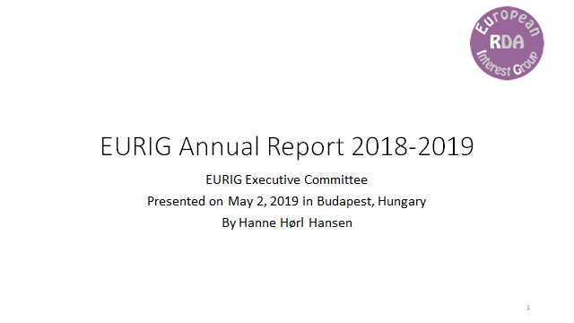
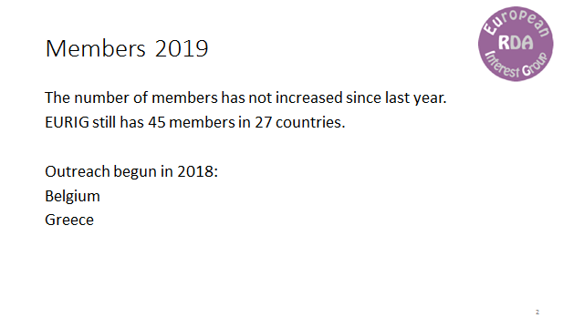
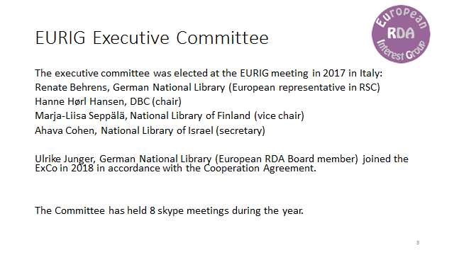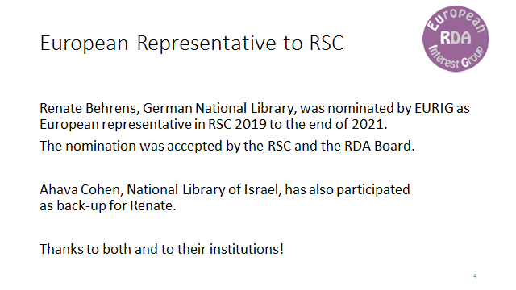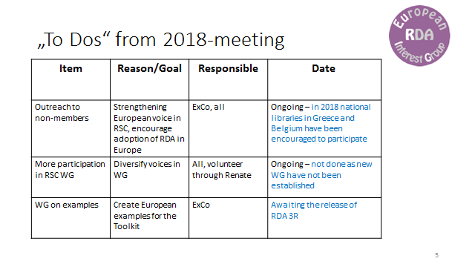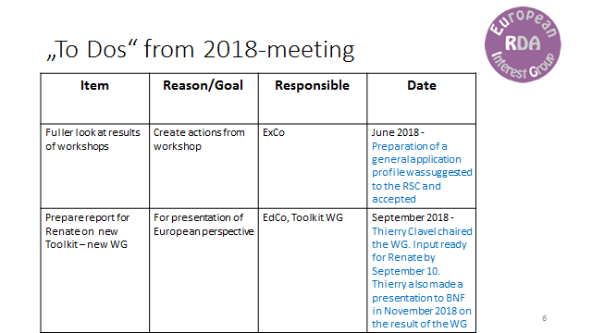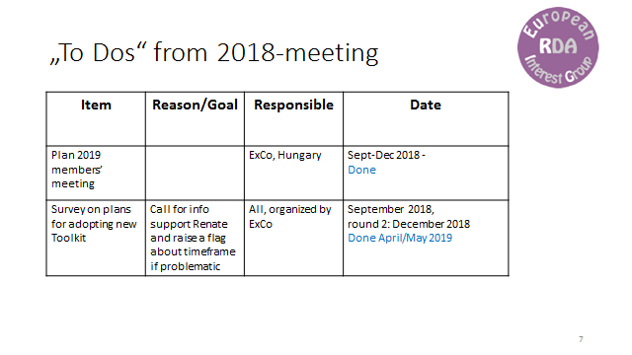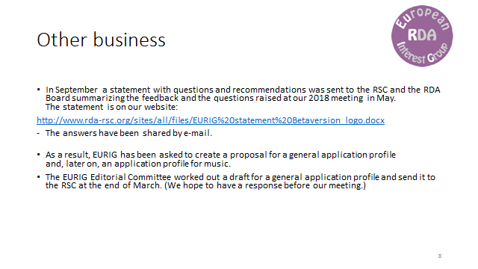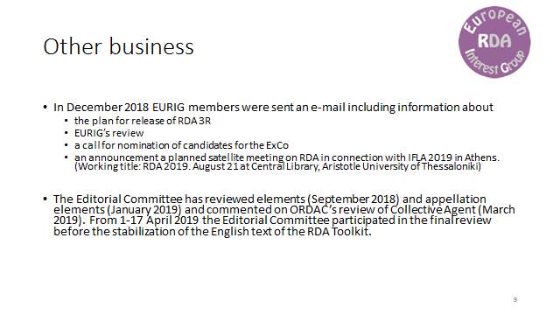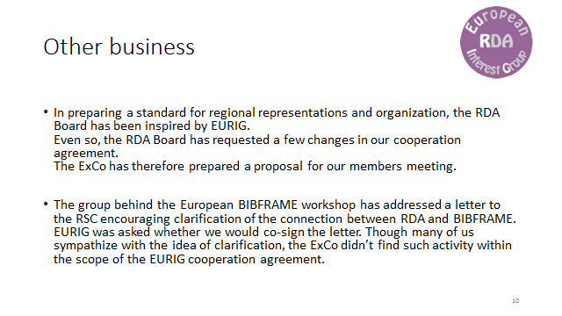

Appendix 3: Report of the Europe Representative to the RDA Board
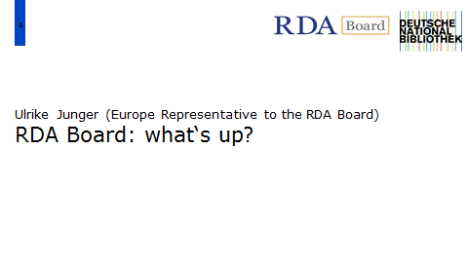
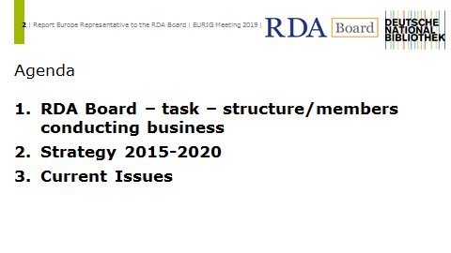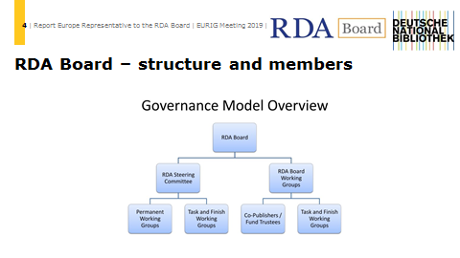
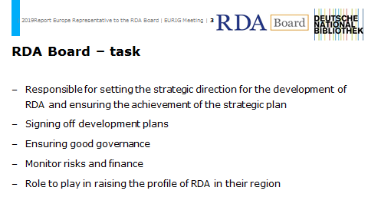
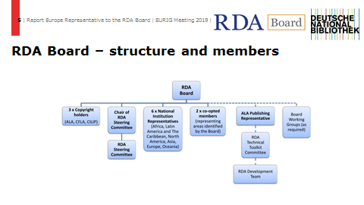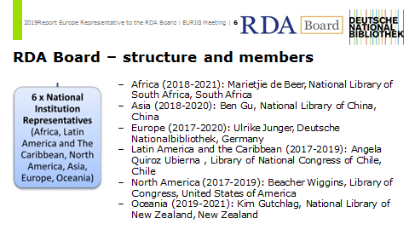
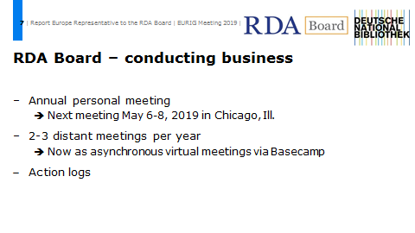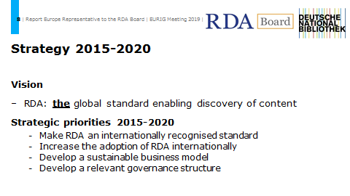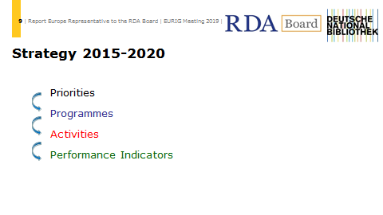
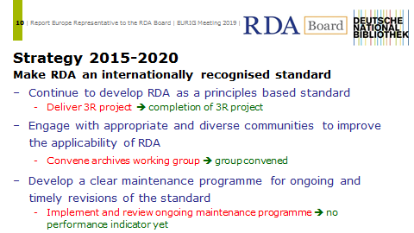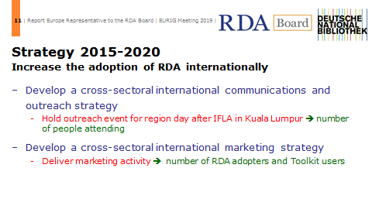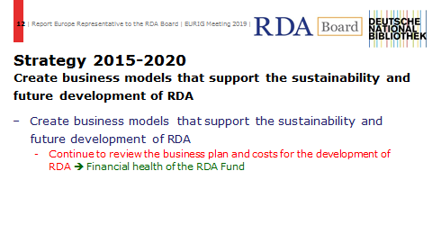
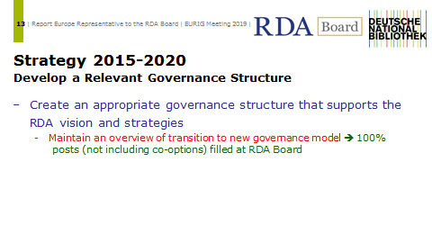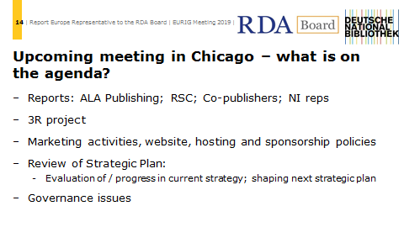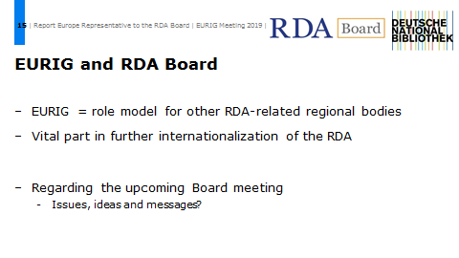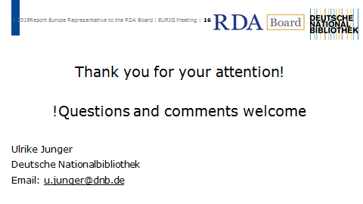

Appendix 4: Report of the European Representative to the RSC
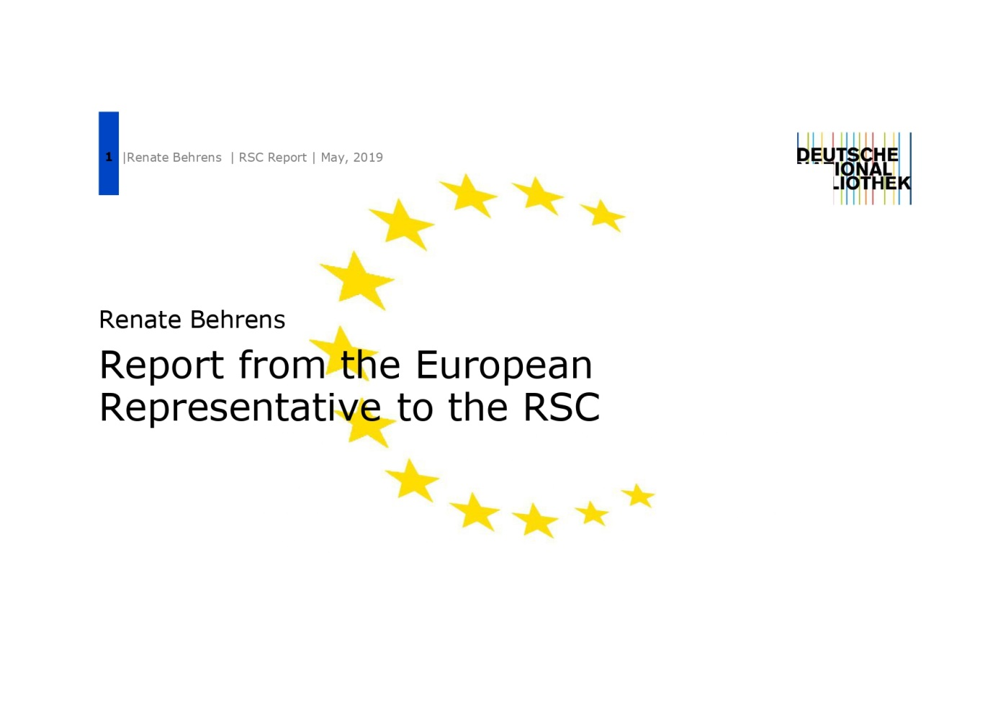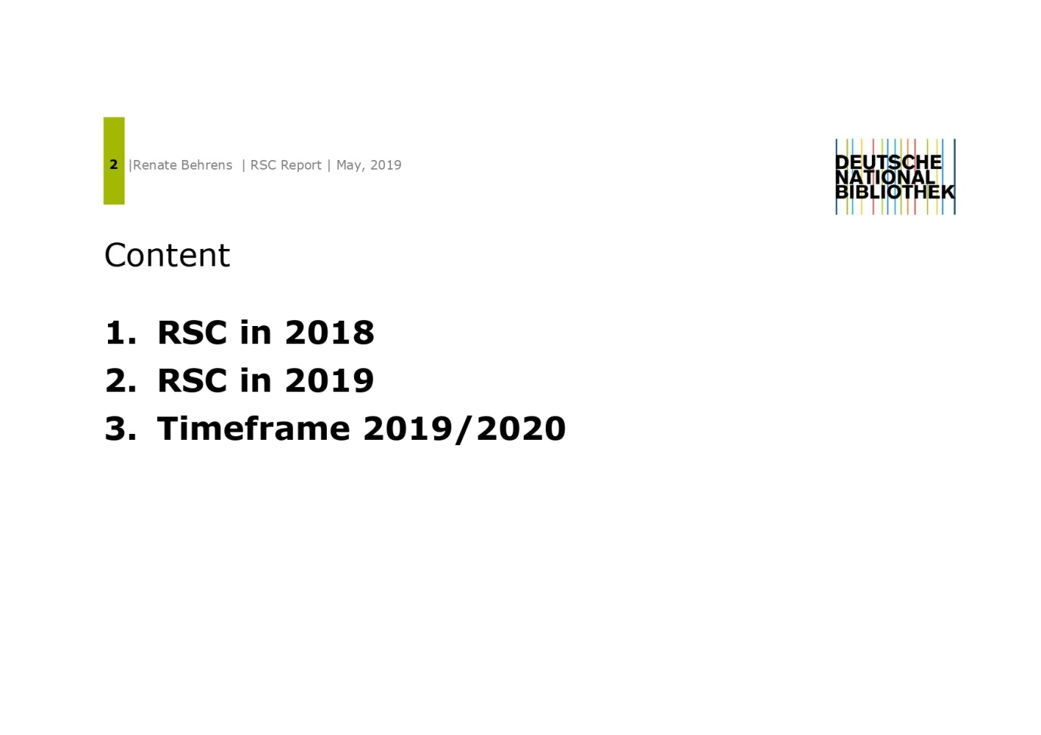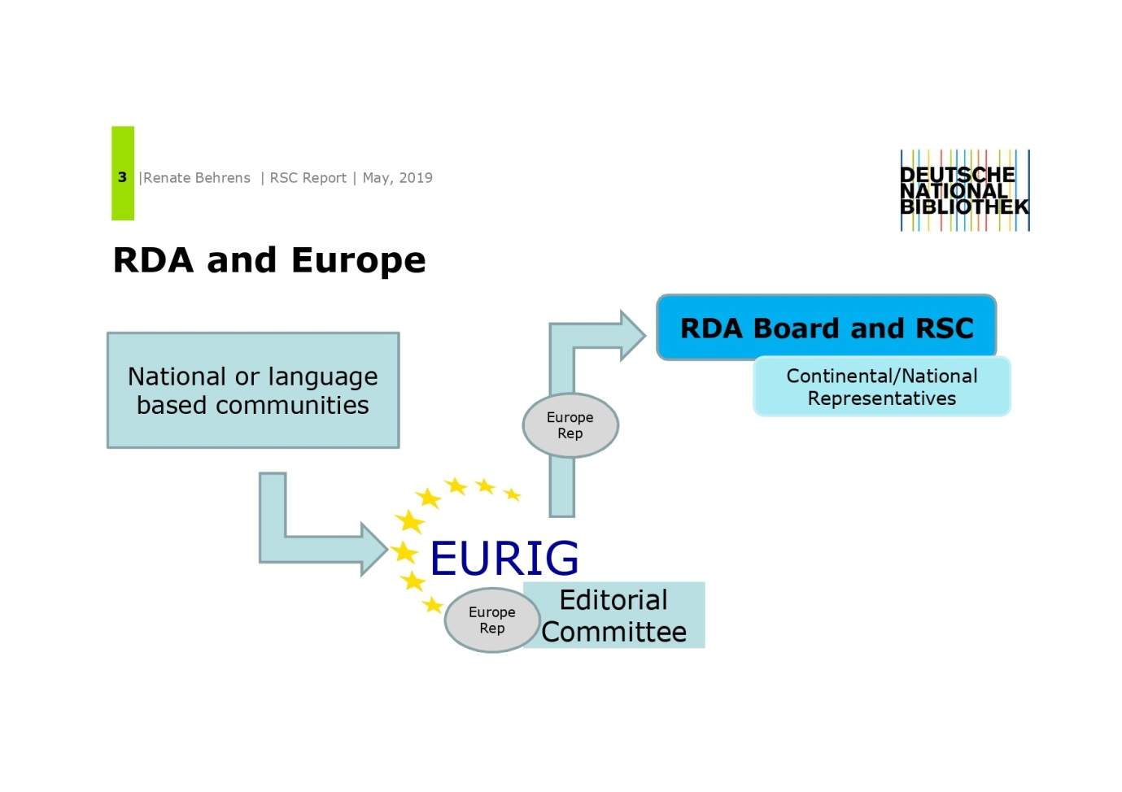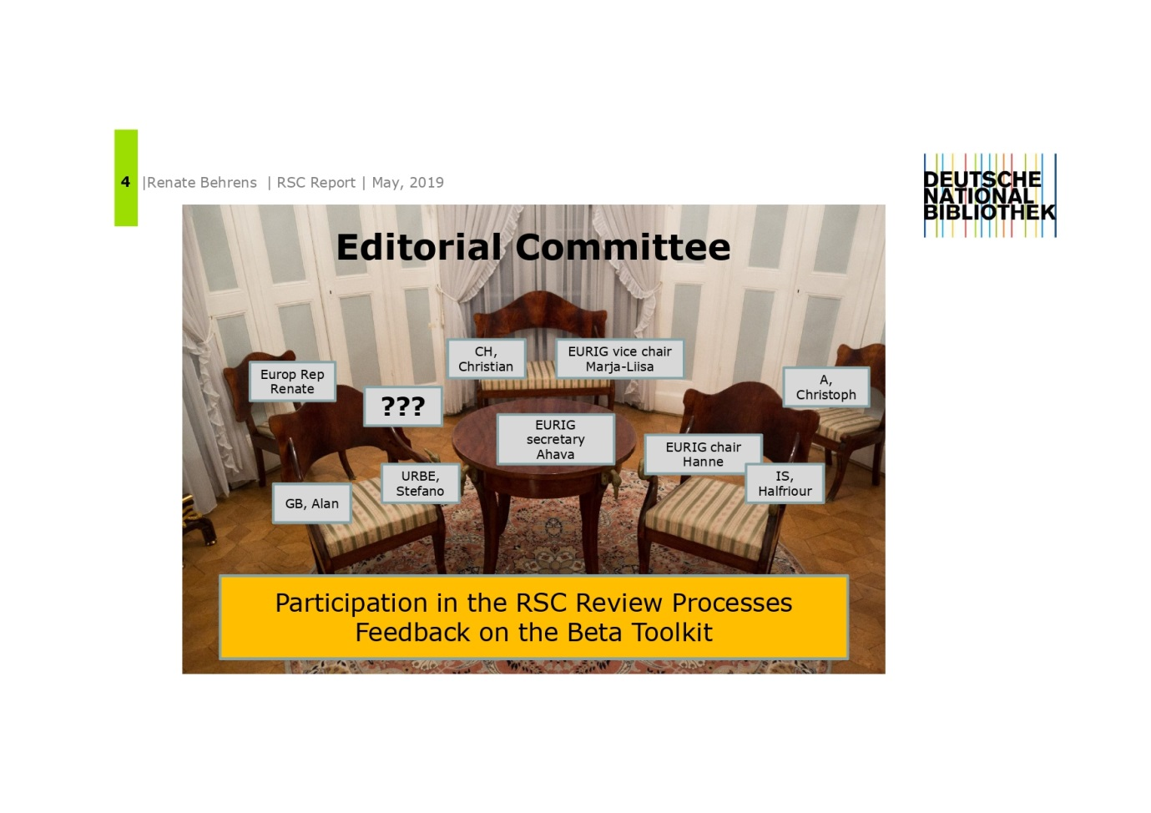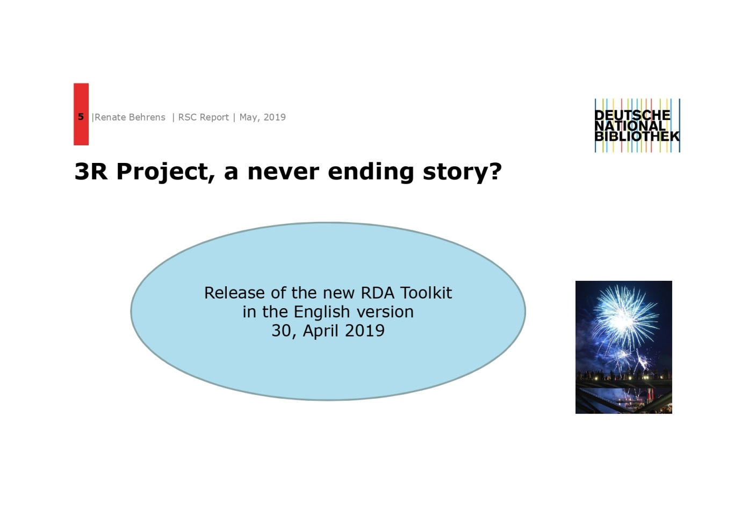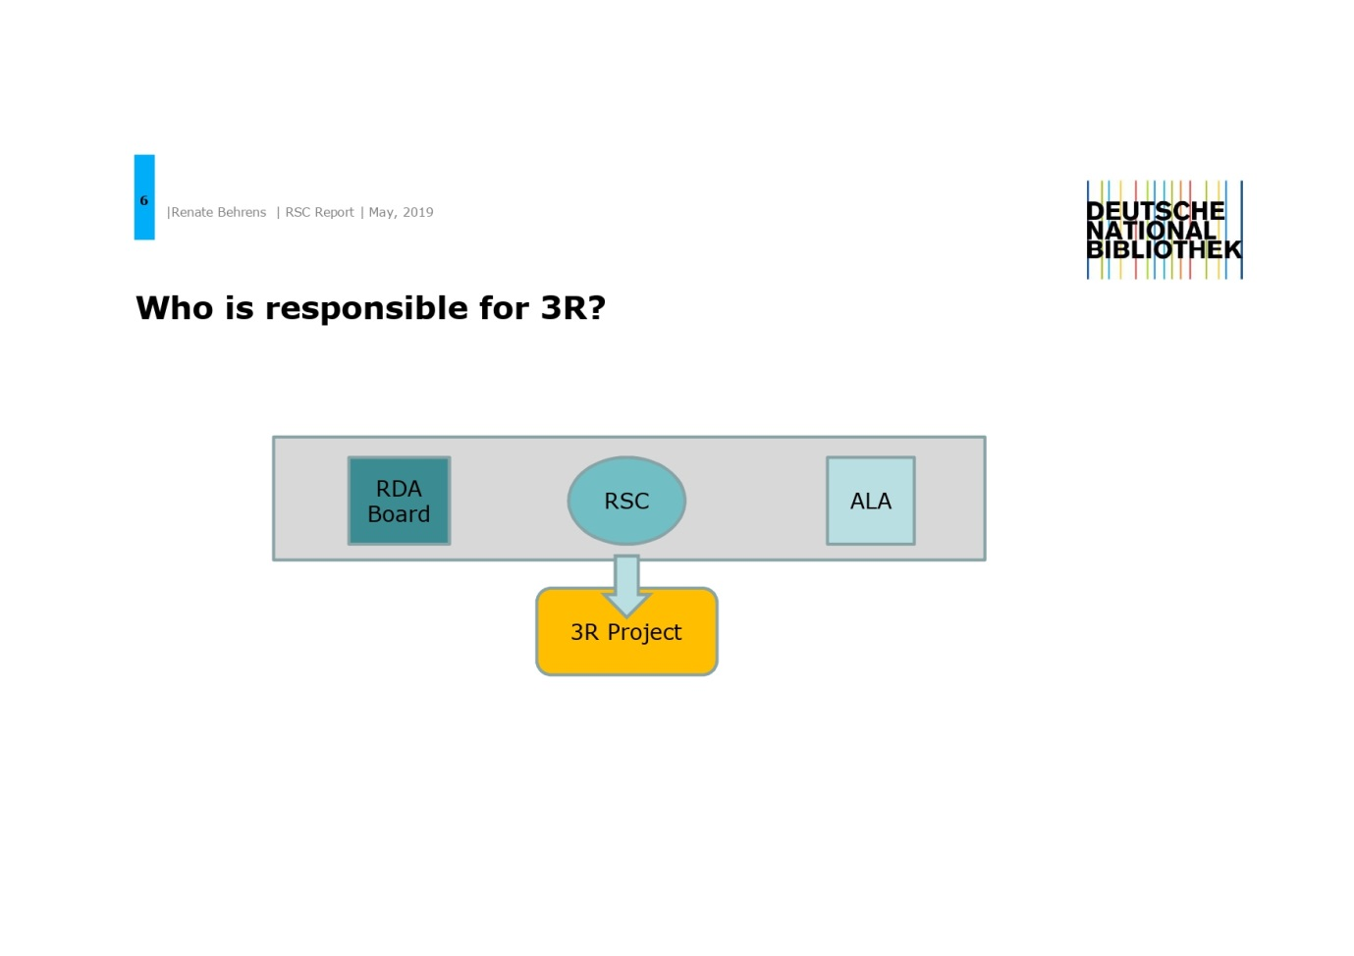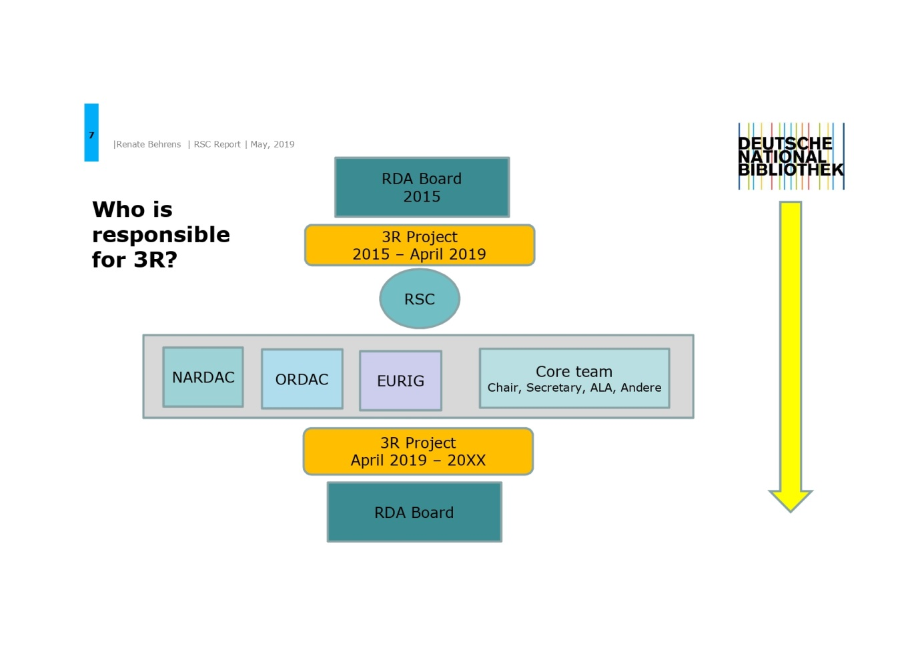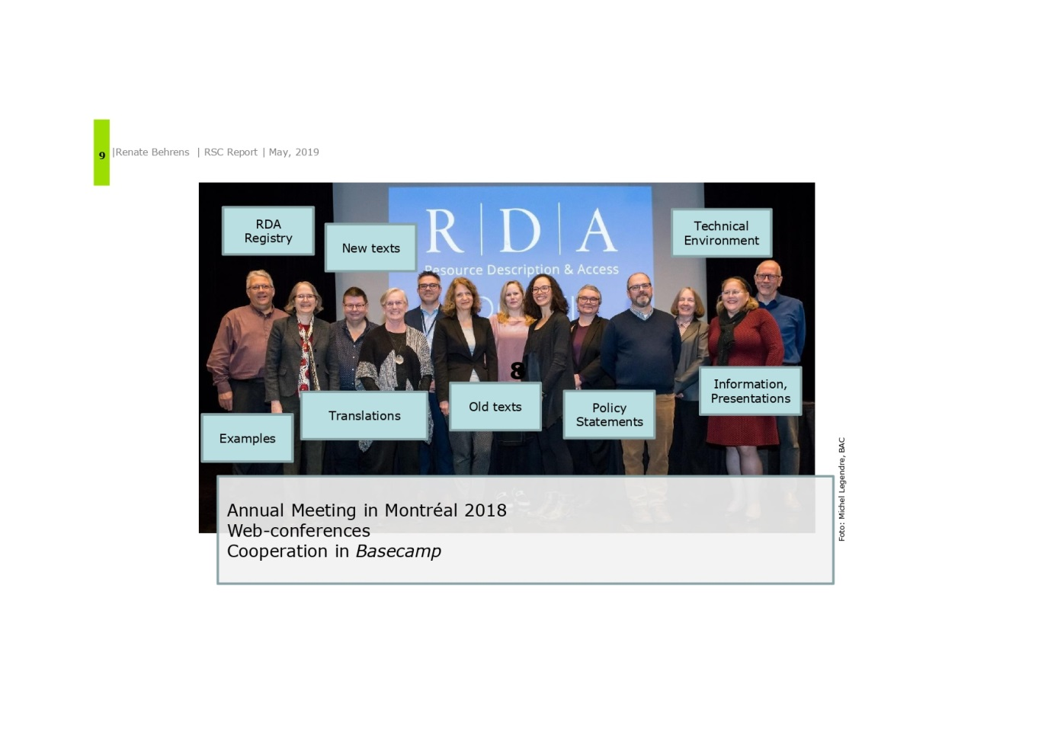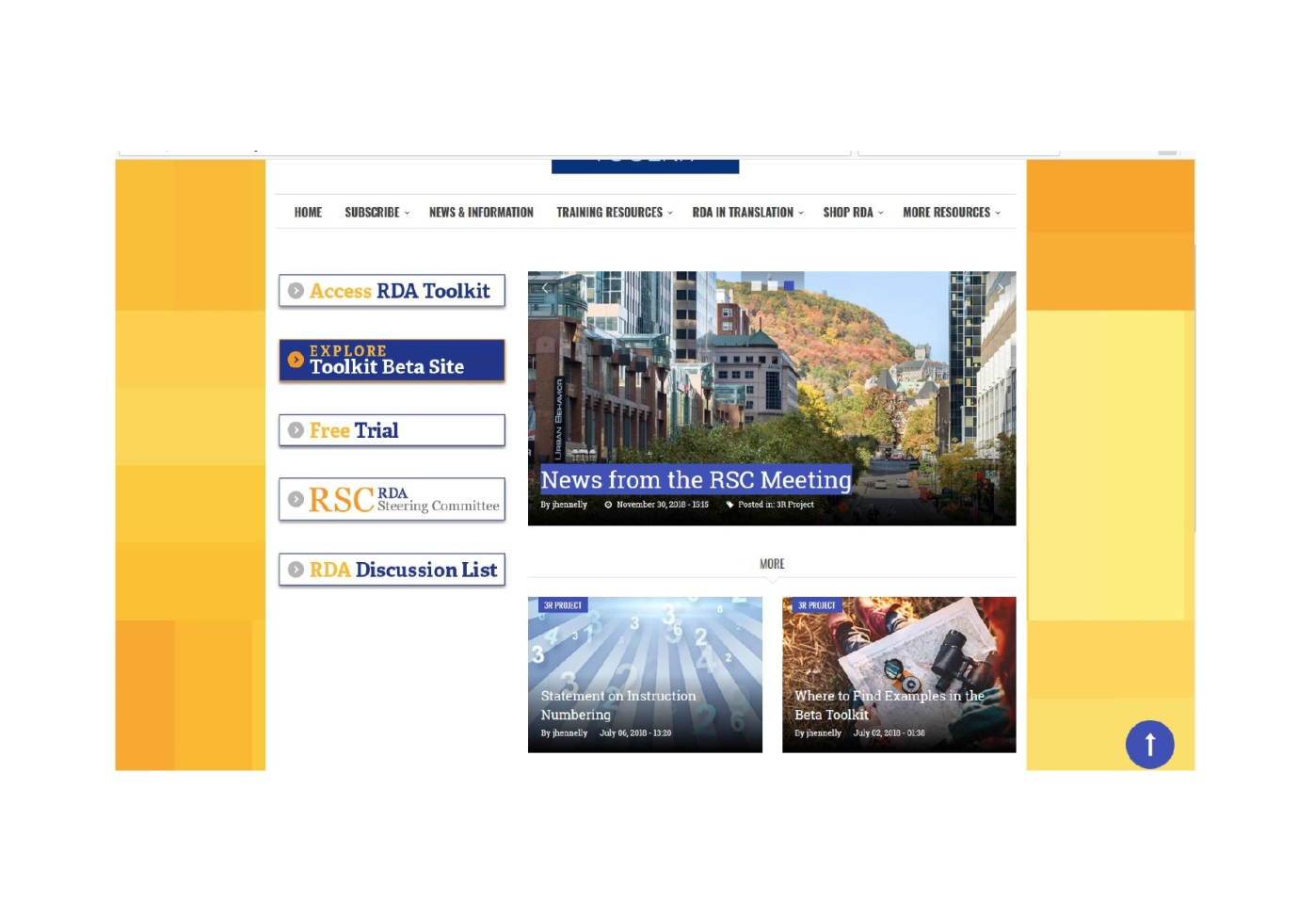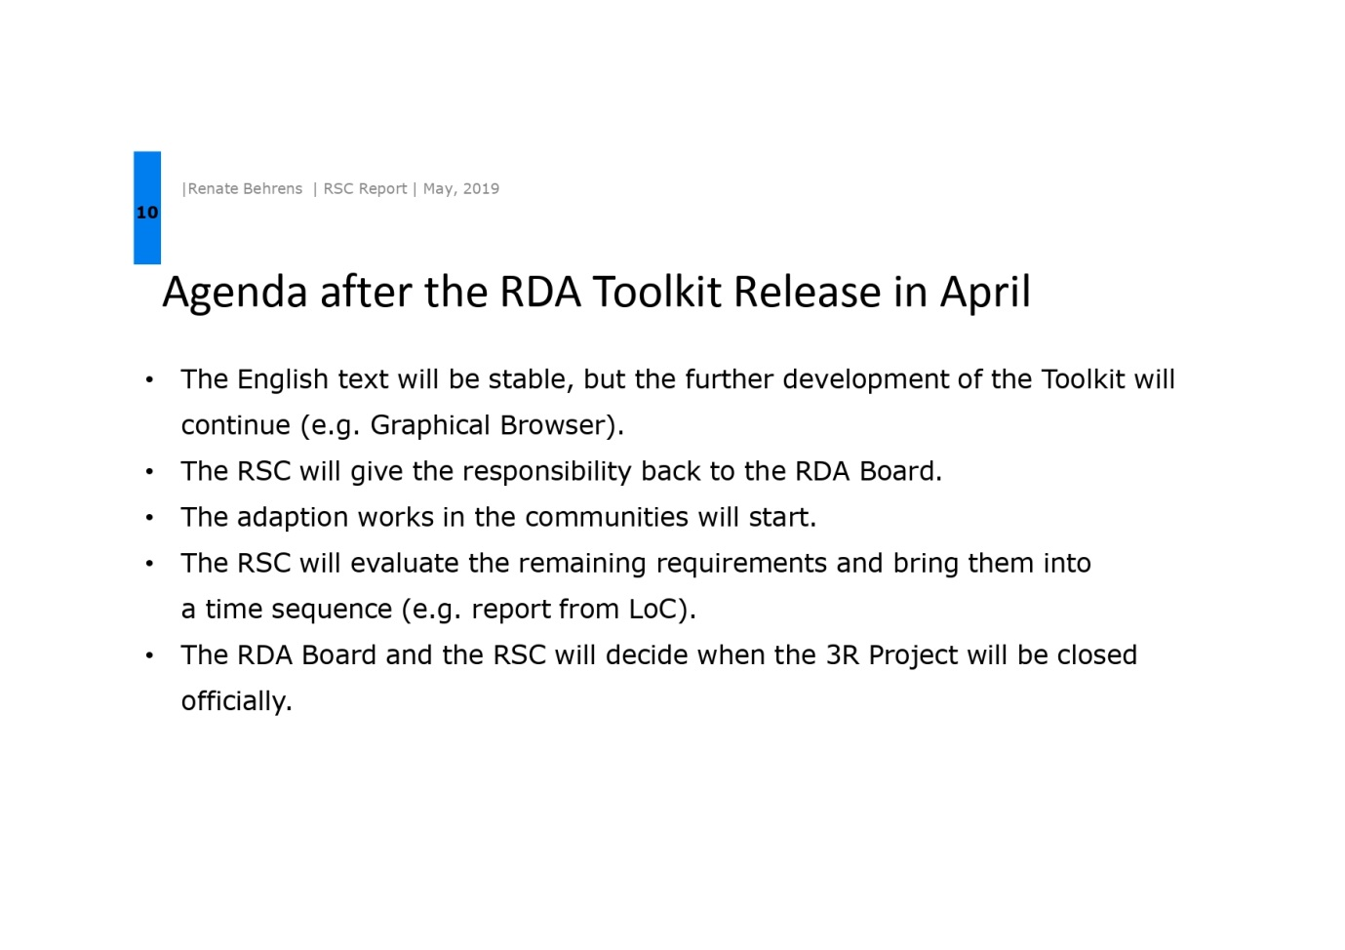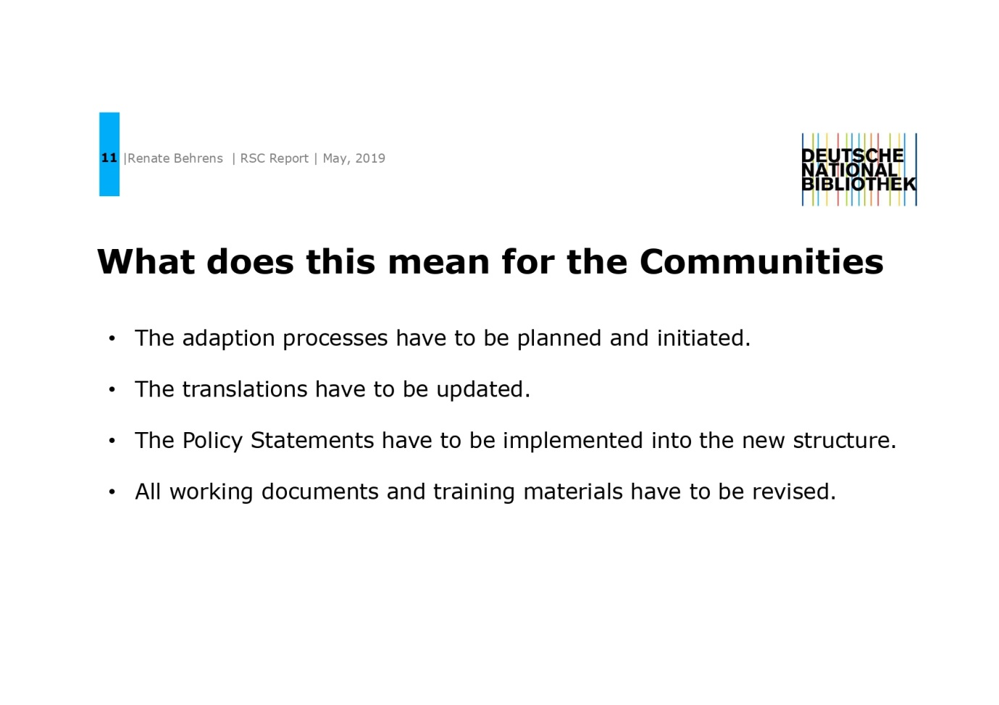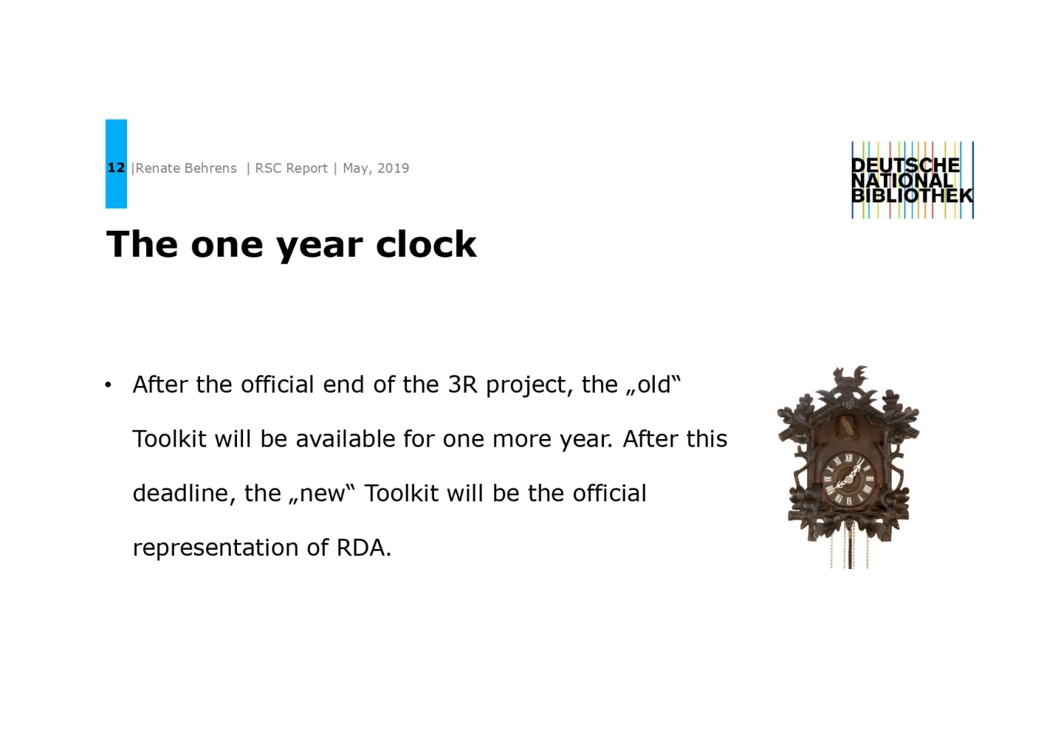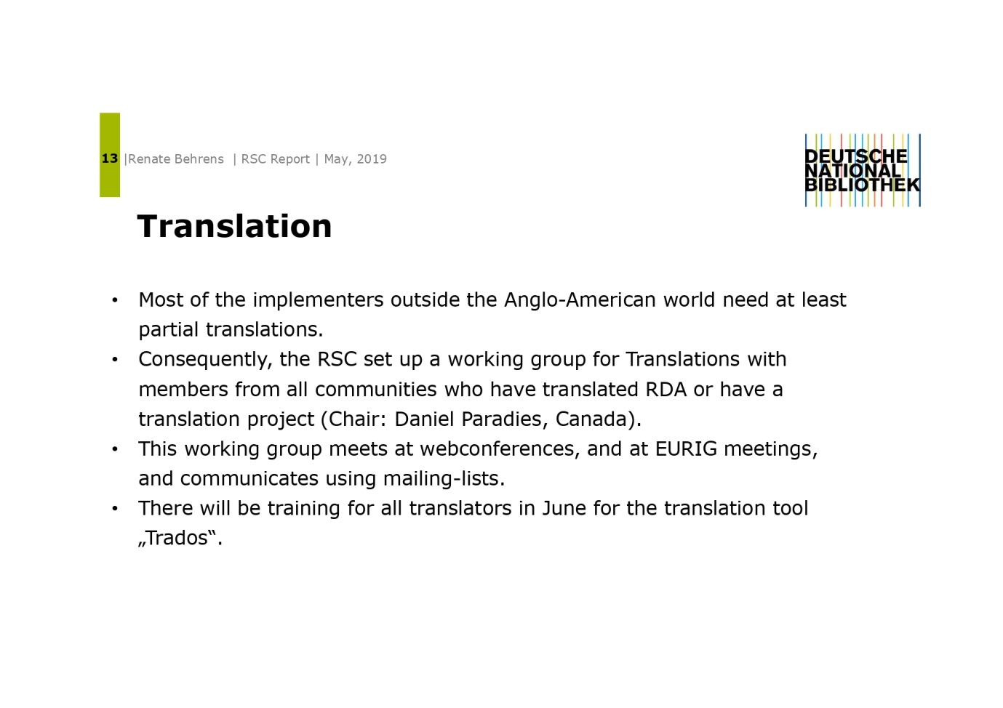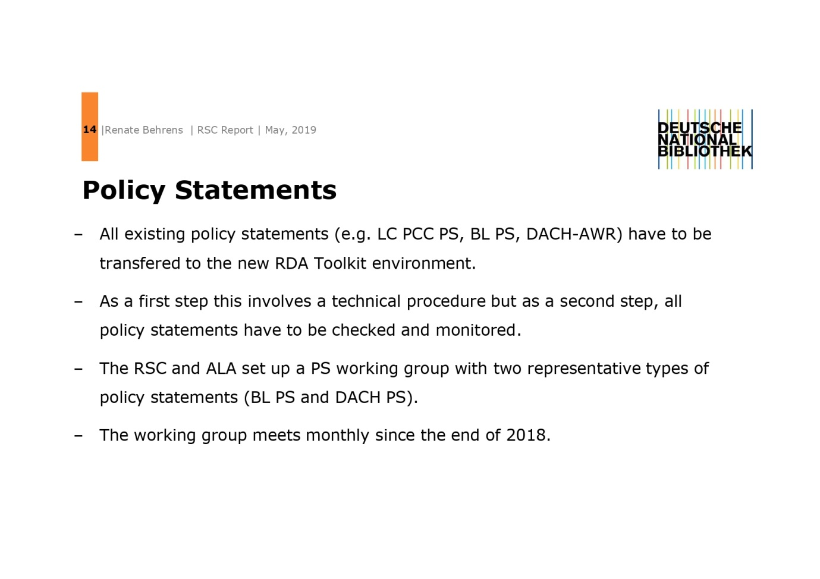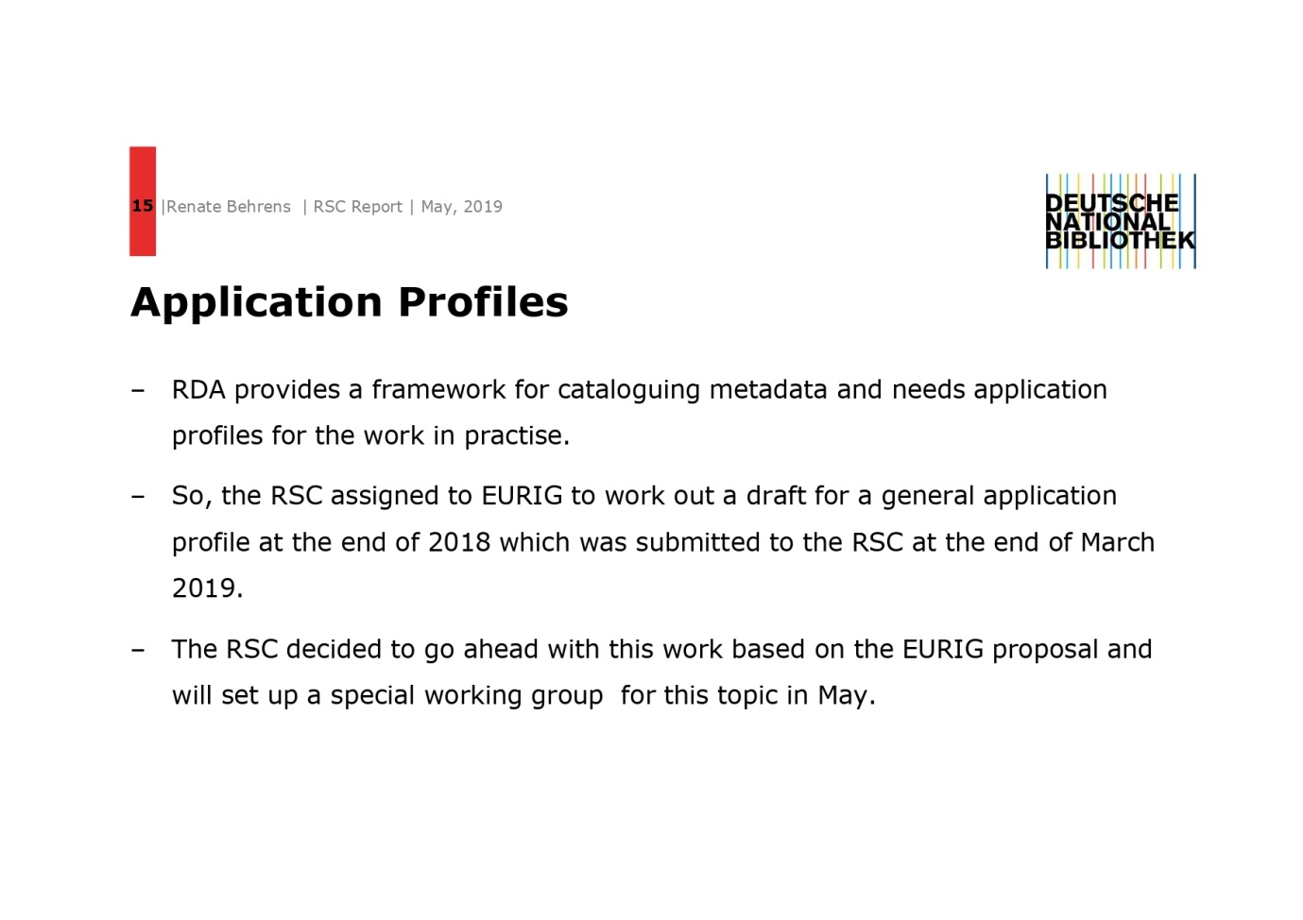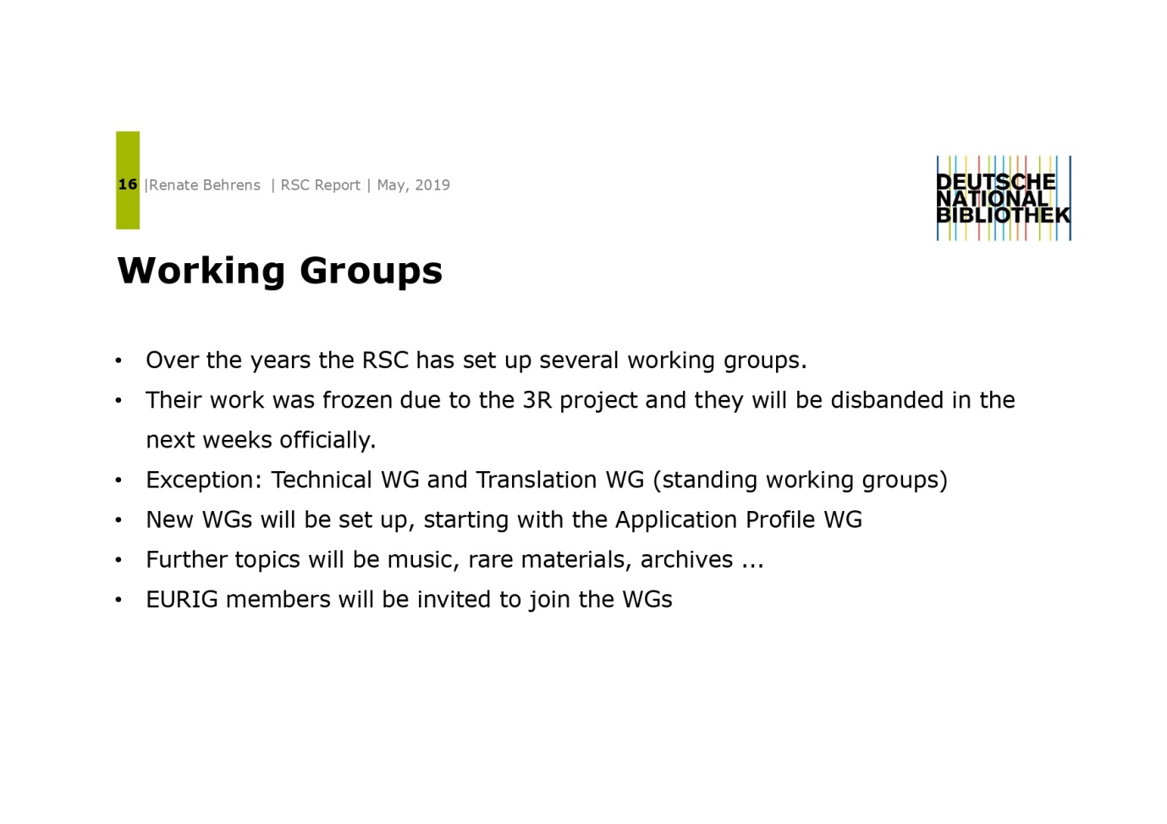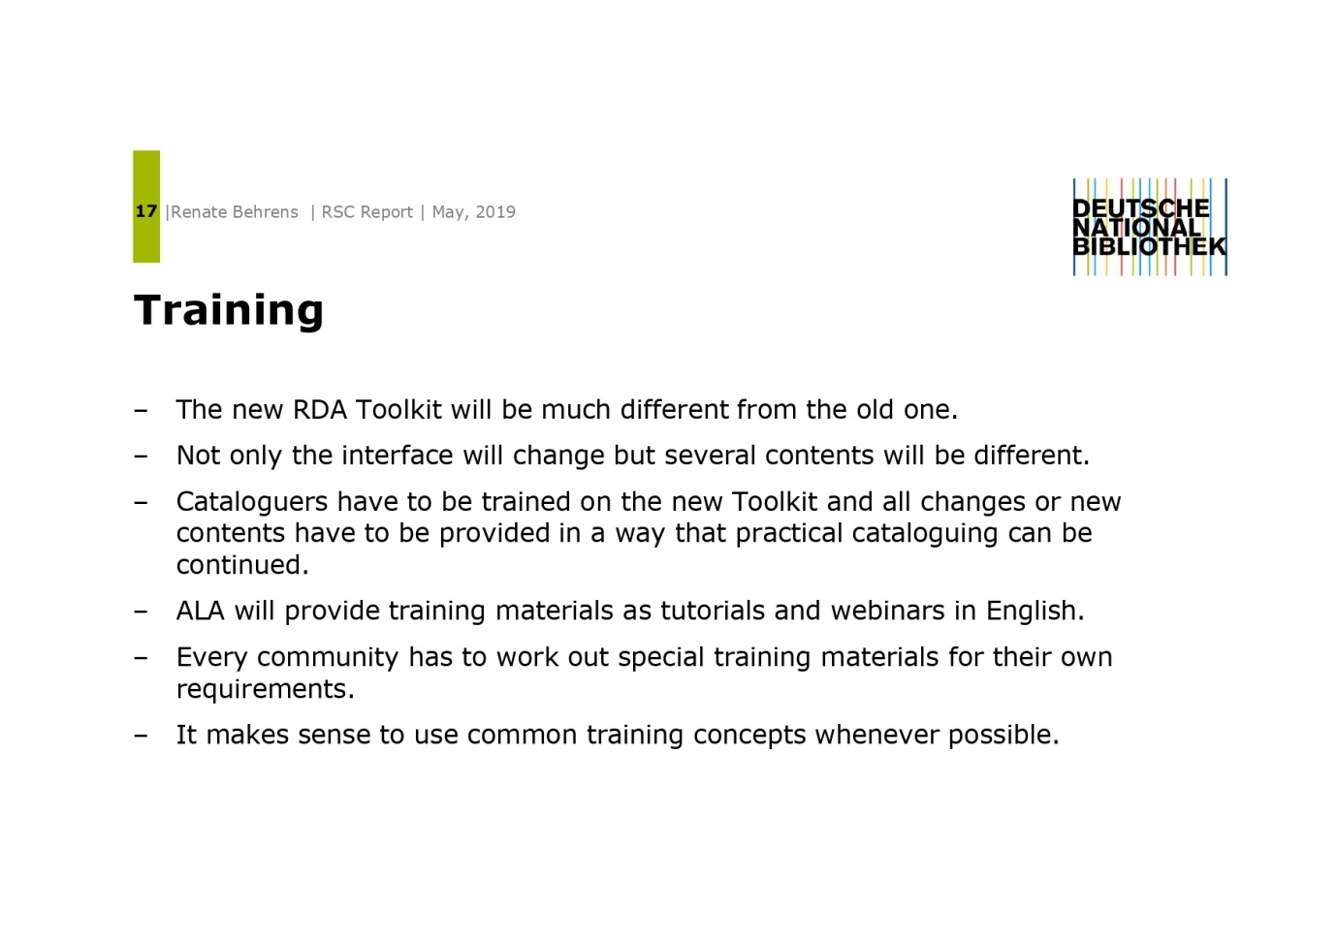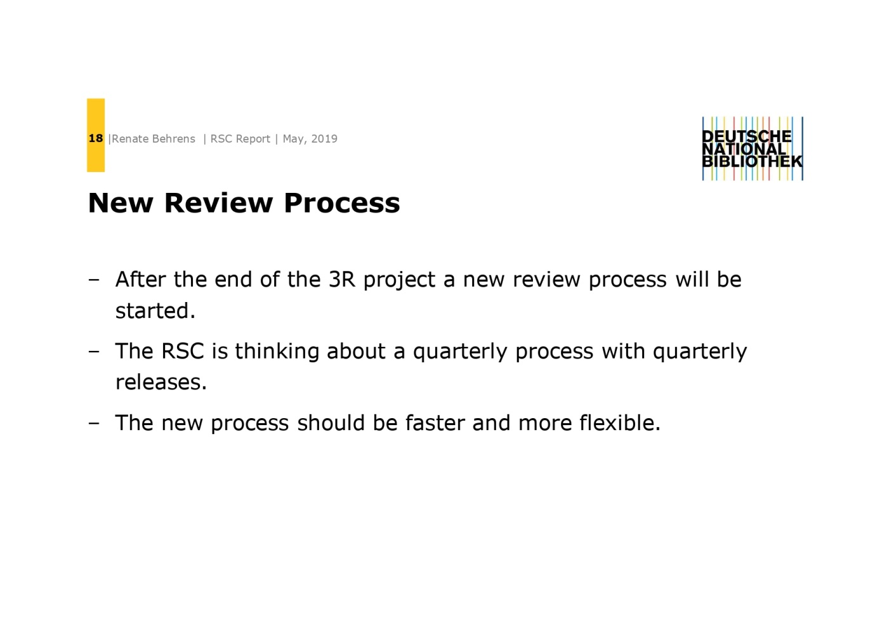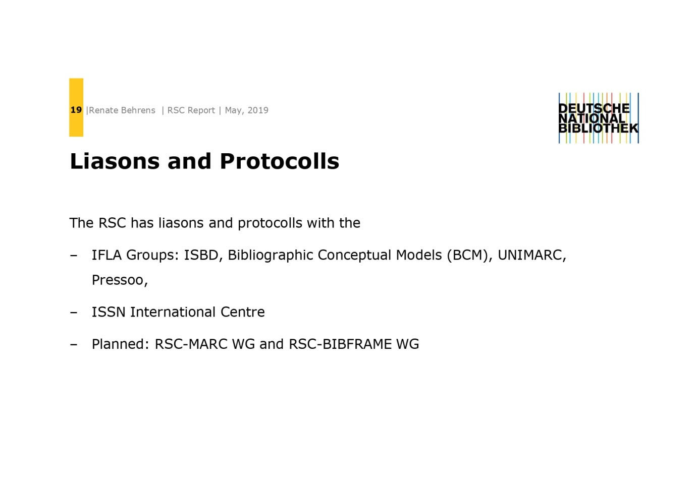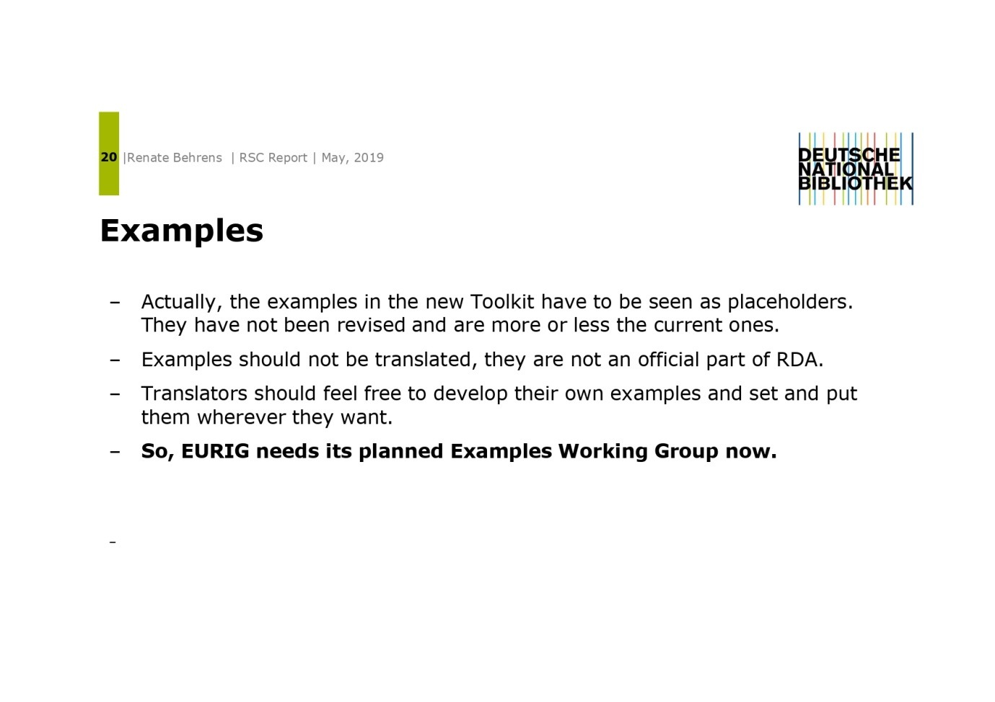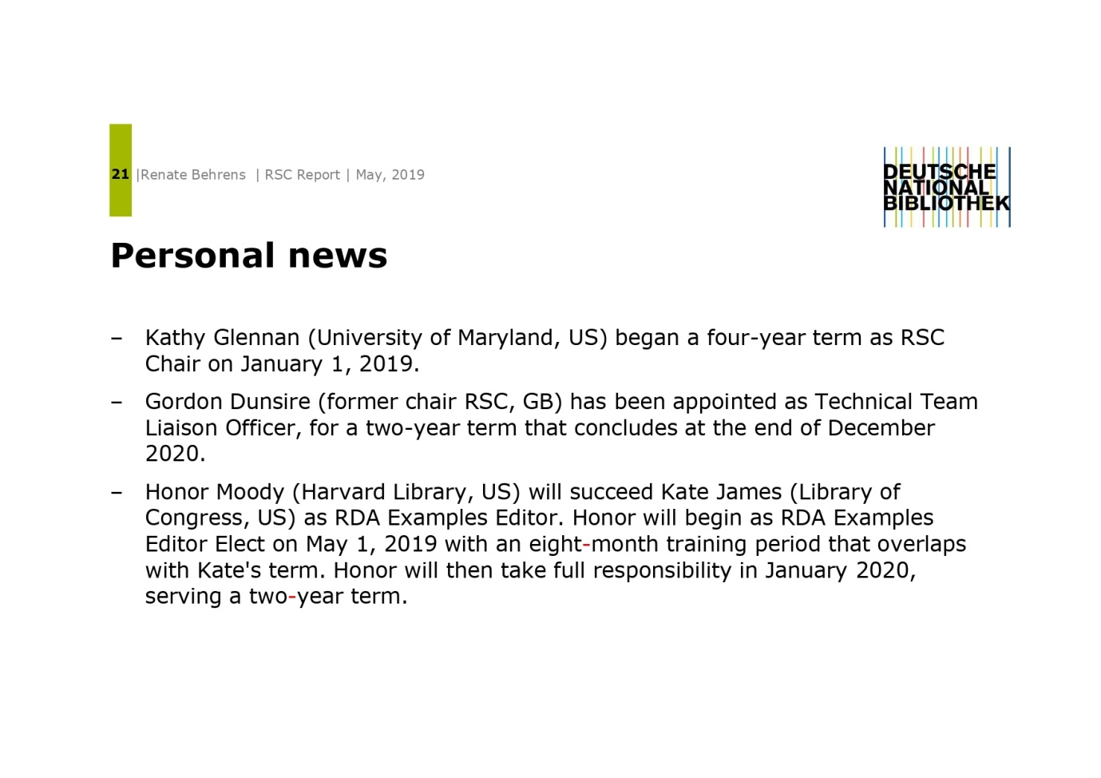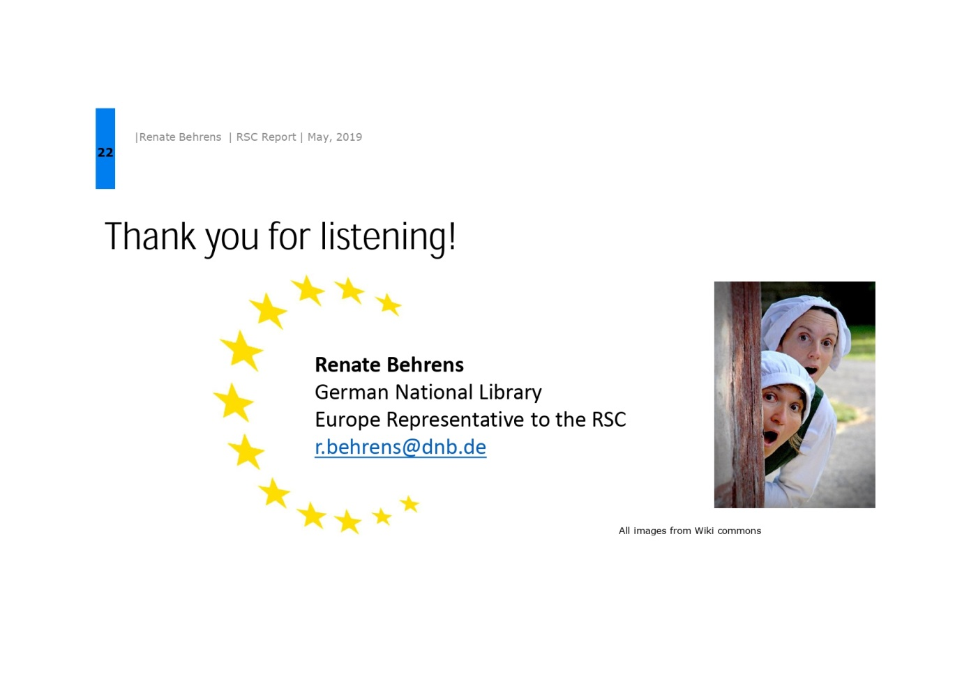

Appendix 5: Report from the European BIBFRAME Meeting
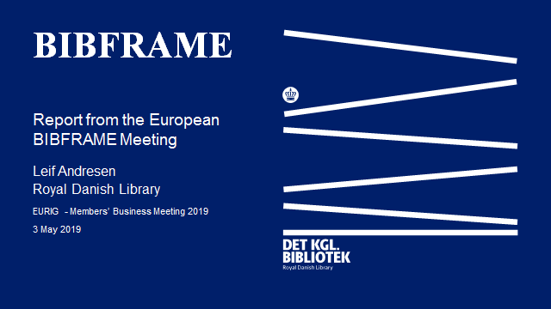
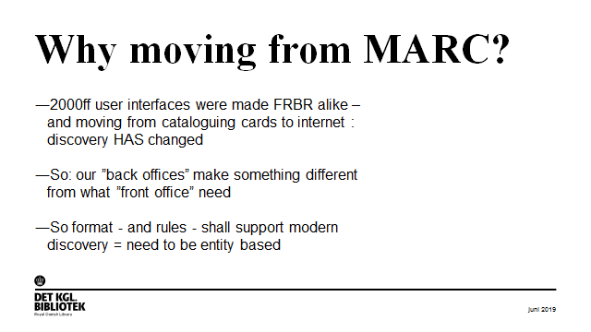

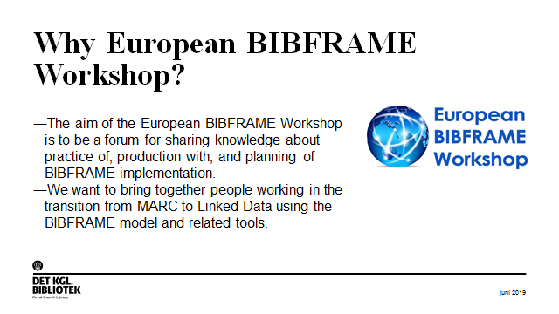
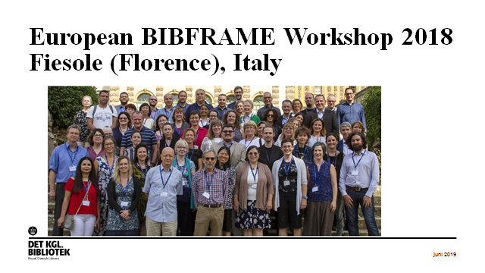
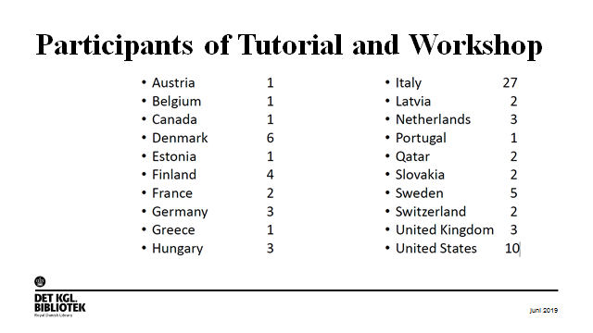
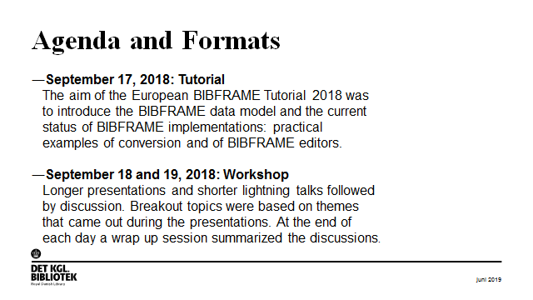
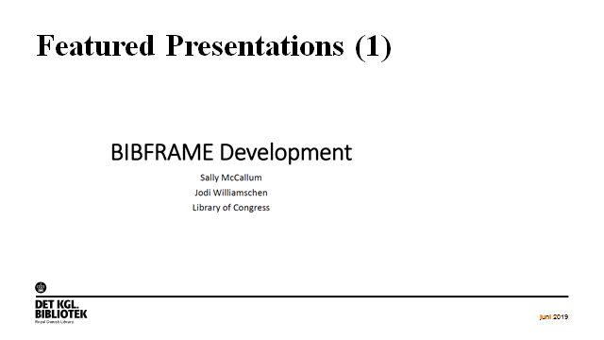
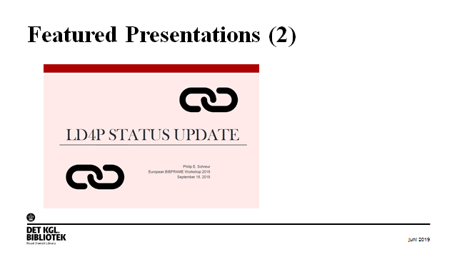

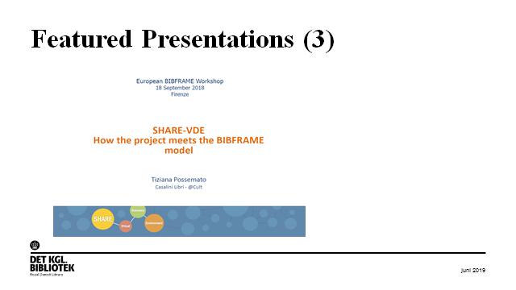
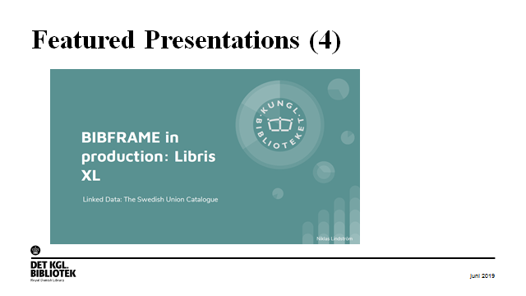
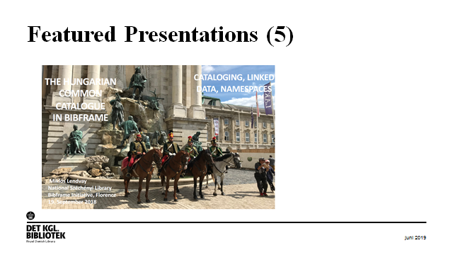
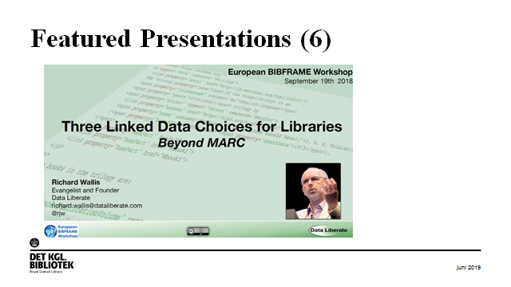
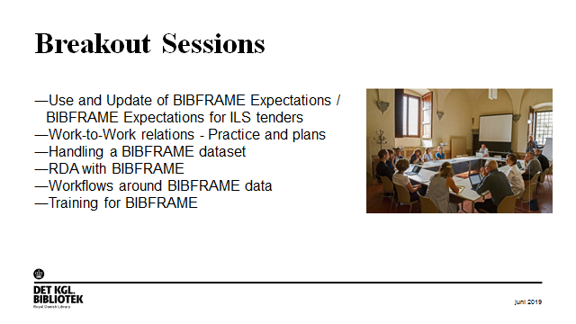
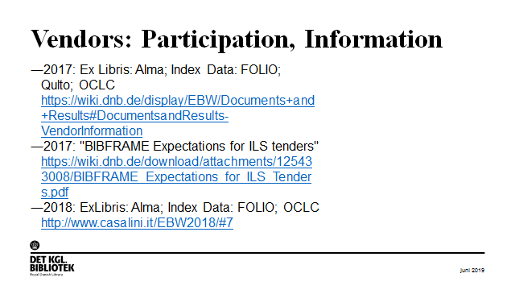
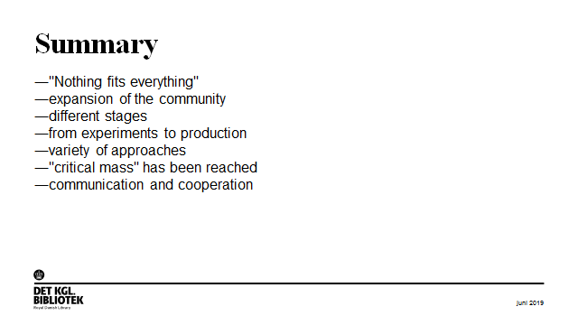
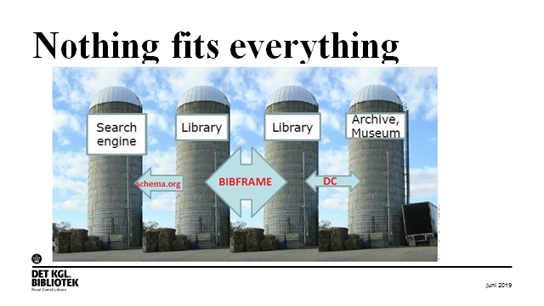
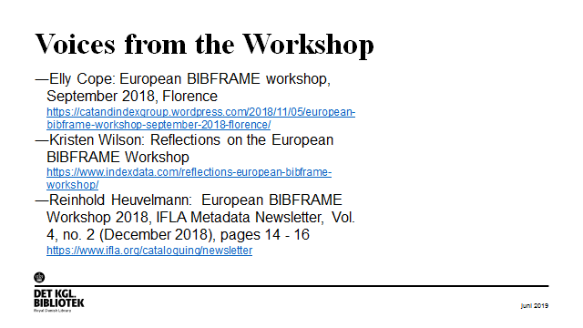
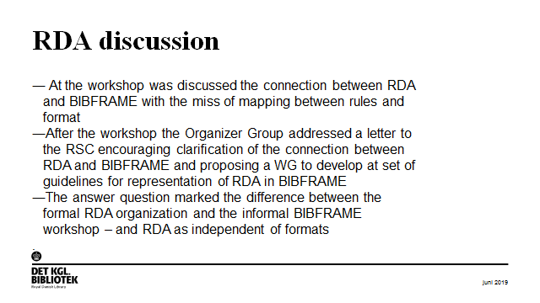
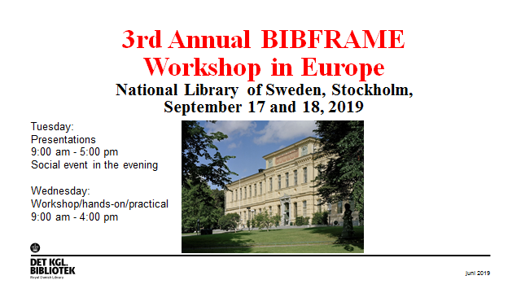
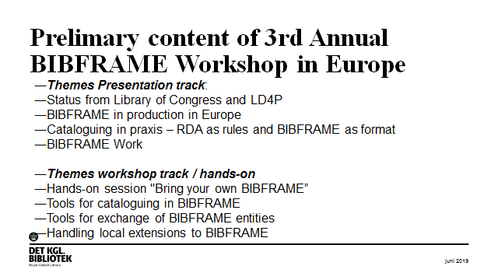
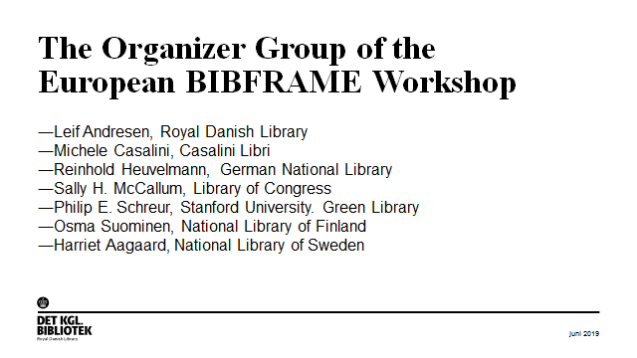
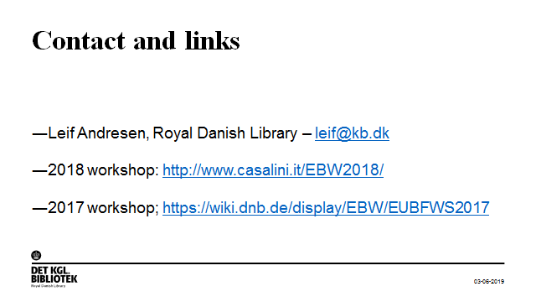

Appendix 6: General Data Protection Regulation (GDPR) and library authority data
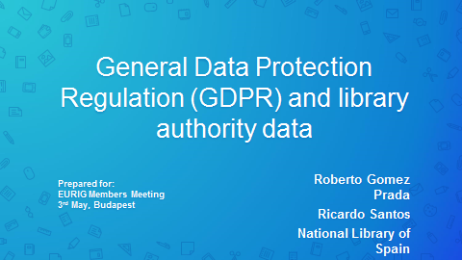
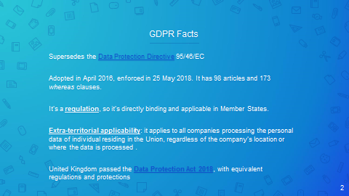
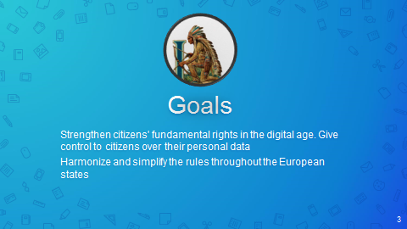
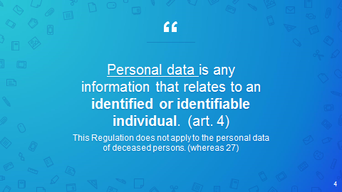
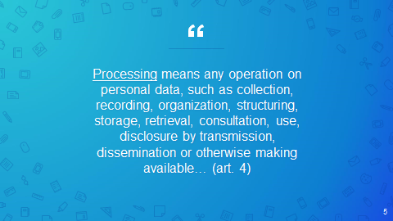
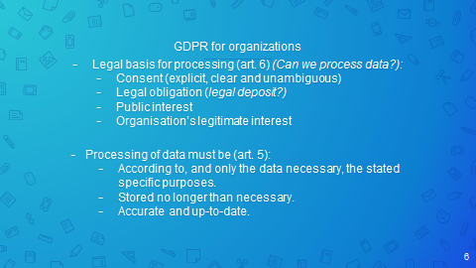
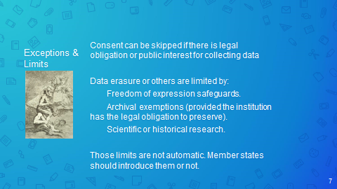
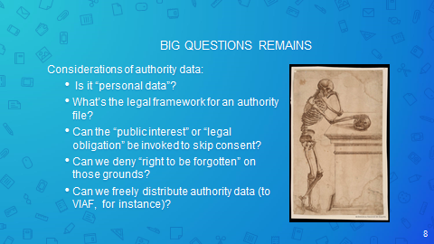
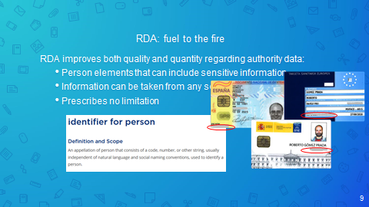
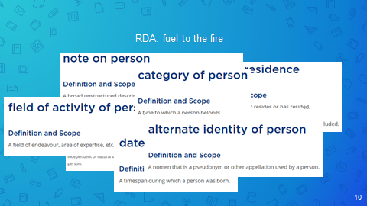
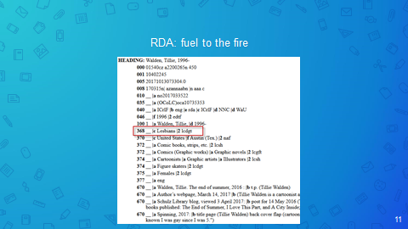
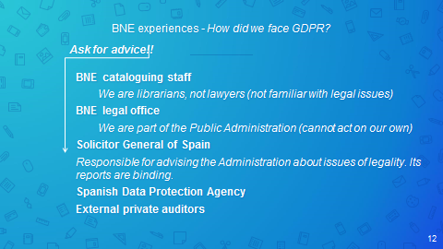
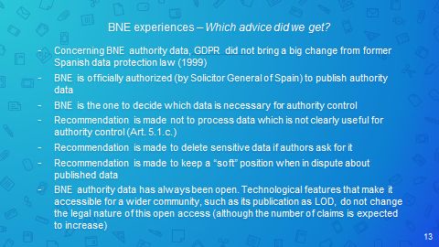
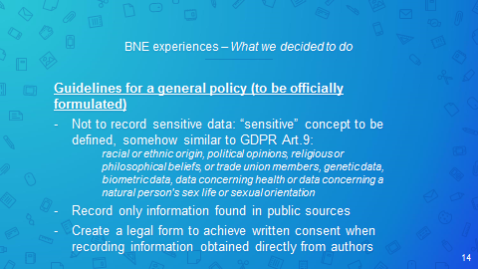
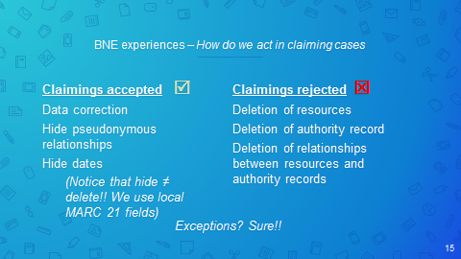
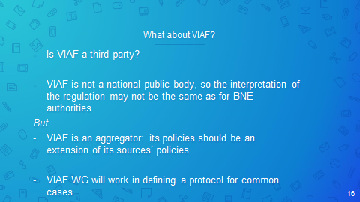
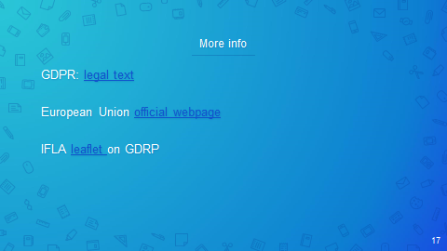
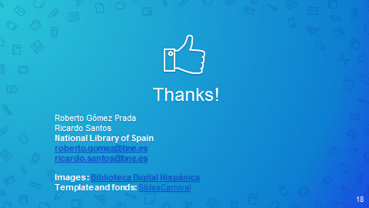

Appendix 7: RDA-FR: the French cataloguing code
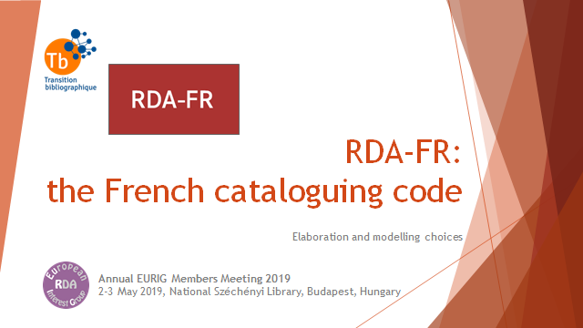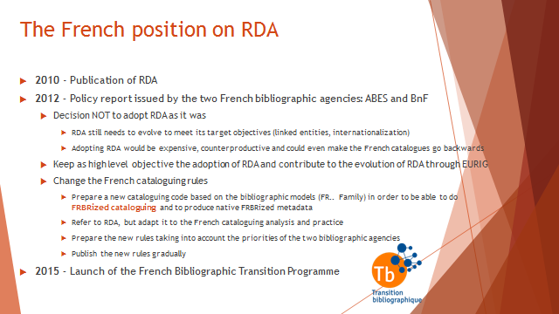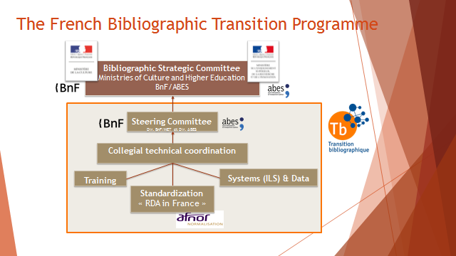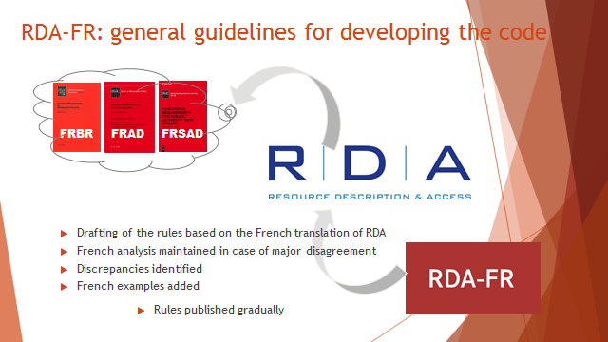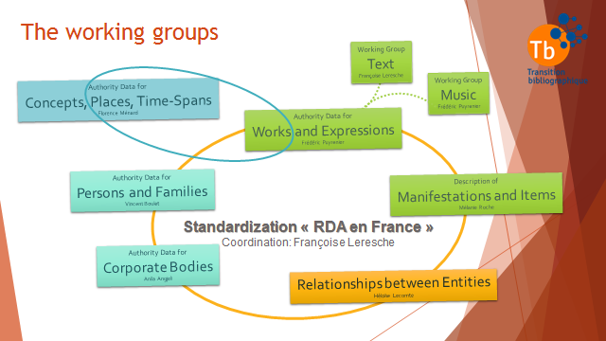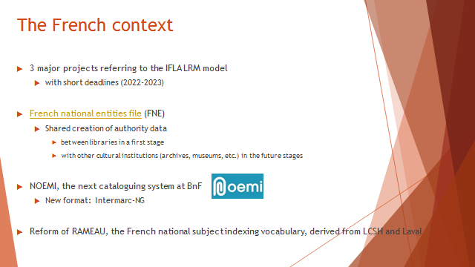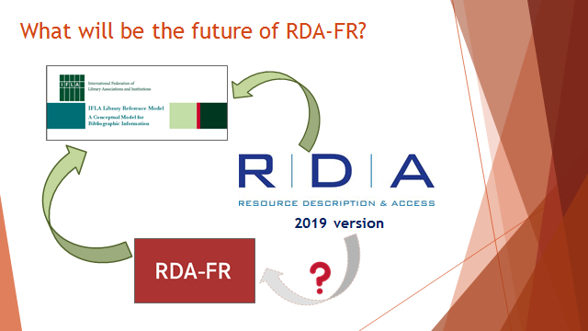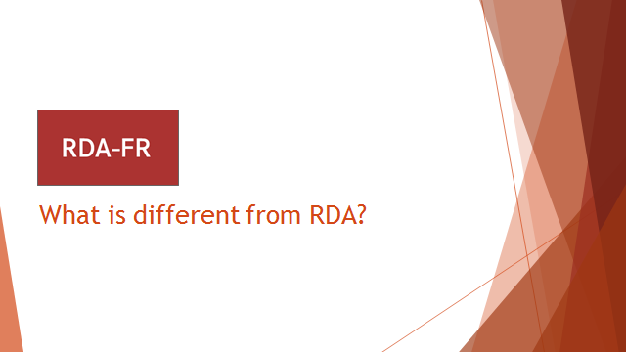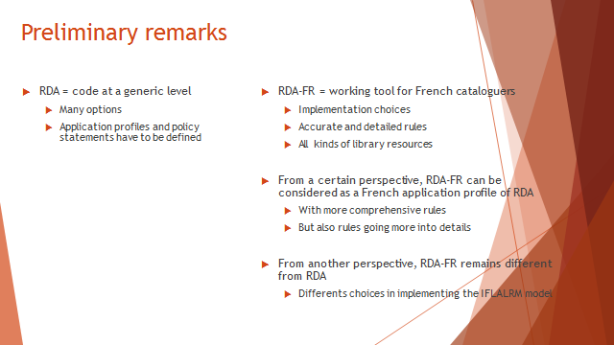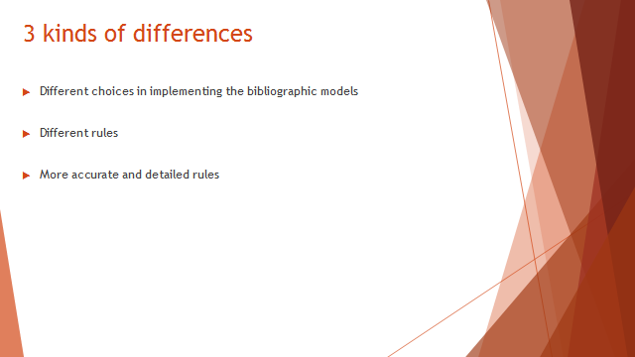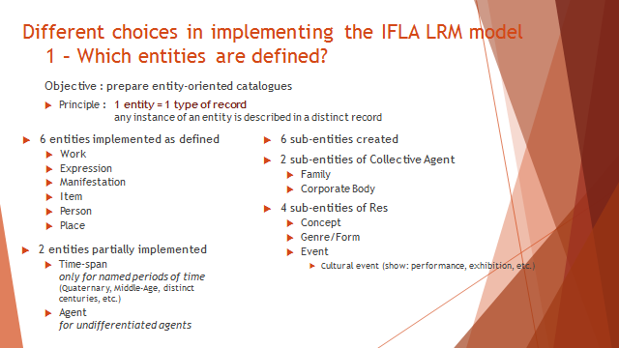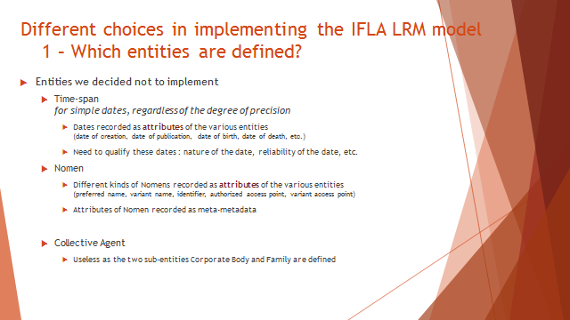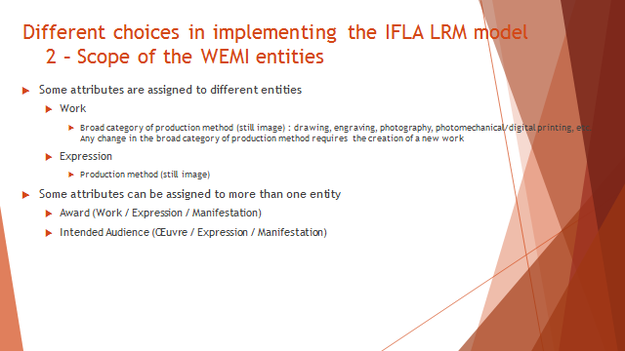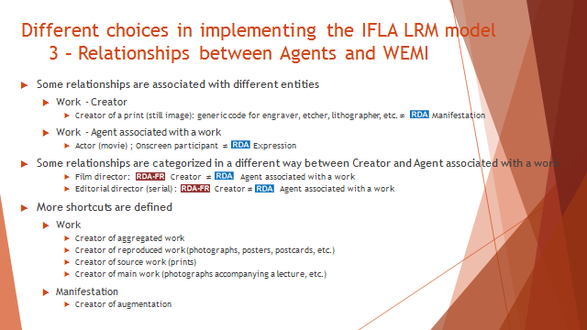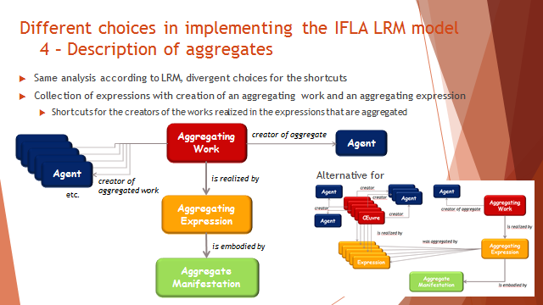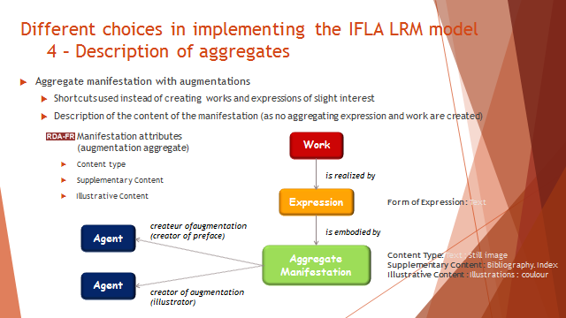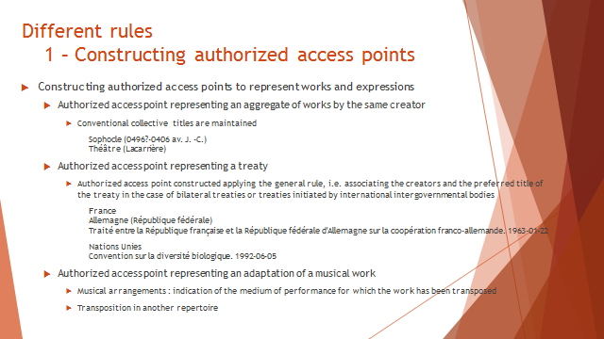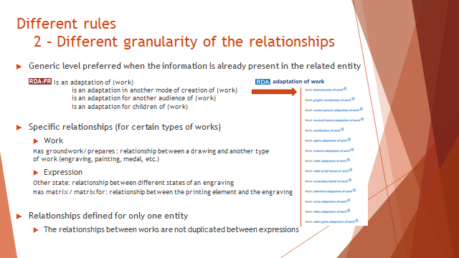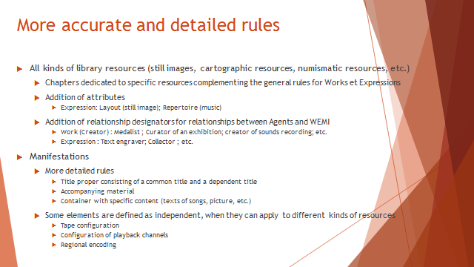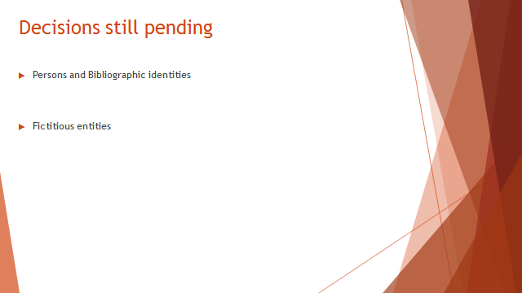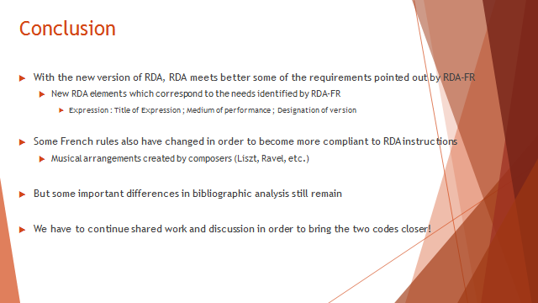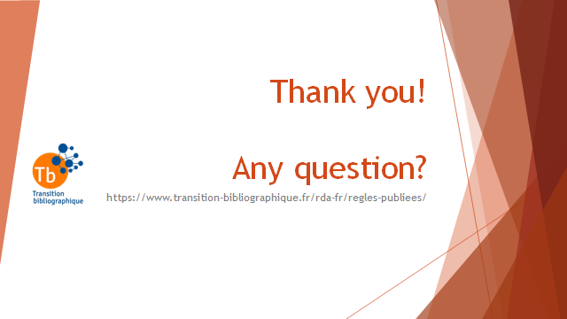

Appendix 8: Authority data for Objects currently identified as Corporate Bodies

Authority data creators in National Library of Latvia quite often faced with cases when they have to describe resources, which focuses on historical buildings (palaces, churches, manor houses, specific architectural and historical buildings) their architecture, construction. RDA rules at present do not offer a solution for modelling relationships between entity Object (named Object) and other related entities (Persons, Families, Corporate bodies). Authority data for such kind of objects are currently being created as institutions, with the possibility to identify them only as Corporate body. In this case, users who seek information about a particular object are misled. Impossibility to distinguish between Corporate body (active agent) and Named Object causes problems in entity identification and data linking, especially in metadata creating for digital resources. National Library of Latvia has collection of printed and digitized visual resources that reflects historical buildings and other objects in Latvia. For example, Corporate body “National Library of Latvia” is not the same as Object – “Building of National Library of Latvia”. They both have different attributes and should be linked as separate entities.
There is an example, which describes this problem:
Example: KGB Building (Rīga, Latvija) currently described as Corporate body | Example: KGB Building (Rīga, Latvija) should described as Geographic name
075 ## |a Institūcija (institution) |b C  – Type of entity “institution” is not correct for entity Object (building).  110 2# |a Stūra māja (Rīga, Latvija)  – named historical object (building), not the institution  368 ## |a Celtnes (Buildings)  – other attributes  370 ## |a Rīga (Latvija)  – related place  371 ## |a Brīvības iela 61, |b Rīga, |d Latvija.  - address  372 ## |a Sabiedriskās ēkas (Public buildings)  -this information is going to MARC field 550 (Topical term)  373 ## |a Latvijas PSR Valsts drošības komiteja  410 2# |a Latvijas PSR Valsts drošības komitejas ēka (Rīga, Latvija)  - other form of name of this object  410 2# |a KGB Gebäude (Rīga, Latvija)  - other form of name of this object  410 2# |a KGB Building (Rīga, Latvija)  - other form of name of this object  410 2# |a Eckhaus (Rīga, Latvija)  - other form of name of this object  410 2# |a Угловой дом (Rīga, Latvija)  - other form of name of this object  500 1# |w r |i Arhitekts (architect person): |a Vanags, Aleksandrs, |d 1873-1919  – related Agent Person to Named Object, not to Corporate body  510 2# |w r Latvijas PSR Valsts drošības komiteja  - Related institution with object - (KGB – Komitet Gosudarstvennoi bezopasnosti). | 034 ## |d Coordinates  046 ## |s 1911  -Date of construction  075 ## |a Type of entity? Object?  151 ## |a Stūra māja (Rīga, Latvija)  – object (building) name  368 ## |a Celtnes (Buildings)  – other attributes  370 ## |a Rīga (Latvija)  – related place  371 ## |a Brīvības iela 61, |b Rīga, |d Latvija.  - address  372 ## |s 1946 |t 1990  – activity period of KGB in this building  373 ## |a Latvijas PSR Valsts drošības komiteja (KGB)  – related group: KGB – Komitet Gosudarstvennoi bezopasnosti  451 ## |a Latvijas PSR Valsts drošības komitejas ēka (Rīga, Latvija)  - other form of name of this object  451 ## |a KGB Gebäude (Rīga, Latvija)  - other form of name of this object  451 ## |a KGB Building (Rīga, Latvija)  - other form of name of this object  451 ## |a Угловой дом (Rīga, Latvija)  - other form of name of this object  500 1# |w r |i Arhitekts (architect person): |a Vanags, Aleksandrs, |d 1873-1919  – related Agent Person to Named Object  510 2# |w r Latvijas PSR Valsts drošības komiteja  - Related Institution with object - (KGB – Komitet Gosudarstvennoi bezopasnosti).  550 ## |g Sabiedriskās ēkas (Public buildings) |z Latvija

Proposed solution:
At present, there is a tendency to create Authority records for churches, palaces and other Named Objects (buildings) as Geographic Names (MARC21 Authority field 151). These objects are more related to geographic names and have attributes as geographic objects. Maybe it is possible to define a separate entity type (Object) for all kind of named objects?
There is an example from DNB – Dom Köln (VIAF ID: 14241677):
151 ## |a Dom Köln |g Köln
451 ## |a Kölner Dom‏ ‎|g Köln‏
451 ## |a Dom St. Peter und Maria‏ ‎|g Köln‏
451 ## |a St. Peter und Maria‏ ‎|g Köln‏
451 ## |a Sankt Peter und Maria‏ ‎|g Köln‏
451 ## |a Dom zu Köln‏ ‎|g Köln‏
451 ## |a Hohe Domkirche St. Petrus‏ ‎|g Köln‏ |0 (DE-101)944304176‏ ‎‡0 (DE-588)4374567-2‏ ‎|0 http://d-nb.info/gnd/4374567-2‏ ‎|a Katholische Kirche‏ |‡b Erzdiözese
510 2# |a Köln‏ ‎‡b Domkapitel‏ ‎‡9 4:affi‏ ‎‡w r‏ ‎‡i Affiliation‏ ‎‡e Affiliation‏

Attributes and relationships, which should appear in the Authority record for entity Object:
1. Type of entity – Object? - MARC21 Authority Field 075;
2. Date of construction of the Object - MARC21 Authority Field 046 subfield $s;
3. It will be nice to have a possibility to add dates to any variant name of Object, so these objects can be called differently in different periods of time.
4. Related Agents – architect, designer, painter, owner, institution - MARC21 Authority Fields 5XX;
5. Address - MARC21 Authority Field 371;
6. Coordinates - MARC21 Authority Field 034;
7. Other related subjects: architectural style, historical events -MARC21 Authority Field 550.
There will be a problem in the future – how to show relationships between RDA entities (PFC) and entity Object? in RDA entity model. Entity type for such kind of Objects is not defined. For example:
(Agent Person) Birkerts, Gunars, 1925-2017 is architect person of (Entity type? Object?) Latvijas Nacionālās bibliotēkas ēka (Building of National Library of Latvia).
(Entity type? Object?) Latvijas Nacionālās bibliotēkas ēka has an architect person (Entity type - Person) Birkerts, Gunars, 1925-2017.
There is even one more controversial type of entity – vehicles like ships, shuttles, etc. They are also described as Corporate bodies, but they are mentioned only as subjects never as active agents. They have owners, builders, designers, technical characteristics; they change their names. There is a need to find a solution for this kind of entity in MARC and RDA.
