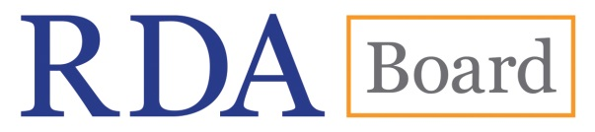
RDA Governance Model

Introduction
Over the past two years, the RDA Board (formerly the Committee of Principals) have been consulting on and developing a new governance model. The overall model was approved in 2015 and the final details regarding selection processes and transition were approved at the meeting in 2016.

This document pulls together the agreed governance model, selection processes and transition plans for both the RDA Board and RDA Steering Committee.

Principles for the new governance model
RDA Board have established a number of key principles for the governance model.

It was agreed that any new structure should:
- Be flexible
- Ensure that current structures become more effective, not less
- Ensure that committees do not become too large (any more than 10-12 people can become un-workable and, specifically in our context, extremely expensive to run)
- Reflect different communities in line with the strategic plan (e.g. non-English speaking communities, cultural/heritage sector, data communities/vendors)
- Use working groups and, occasionally, contractors to deal with the volume of work
- Ensure that there is adequate succession planning
- Take into account existing structures that can be built upon and leveraged
- Take into account changes to processes which will need to be implemented as a result
- Have a transition period

Any new model must adhere to these principles.

RDA governance model
The overall governance model can be found at Appendix 1. This brings together the best of what is working at present, but reflects key issues which rose through the consultation. The suggested model remains flexible; enabling changes to the external environment to be reflected in the governance model.

The model refers to International Regions. These are defined using the UN regions: http://unstats.un.org/unsd/methods/m49/m49regin.htm

Any country on the border with another region can ask to be covered by a different region if it makes sense because of language or a history of partnership working. Such requests should be discussed with the Chair of the RDA Board and Chair of the RDA Steering Committee. If approved, this should be documented on the RDA-RSC website for future reference.

RDA Board
The RDA Board is responsible for setting the strategic direction for the development of RDA.
They sign off development plans, ensure good governance, monitor risks and finance and ensure that the strategic plan is achieved. They also have a role to play in raising the profile of RDA in their region.

The structure of the RDA Board can be found at Appendix 2.The Board will consist of:

Core members

3 x Copyright holders

Chair of the RDA Steering Committee

Rotating Representatives

6 x National Institution representatives (Africa, Latin America and the Caribbean, North America, Asia, Europe, Oceania)
- 2 x Co-opted representatives (optional)
Additional attendees
In addition, a representative from ALA Publishing will be in attendance.

If a Board Member is unable to attend the meeting, an appropriate substitution will be allowed. The substitute will be able to vote in the event that a vote is required.

Copyright holders
Each of the co-owners of RDA (American Library Association (ALA), Canadian Federation of Library Associations (CFLA) and Chartered Institute of Library and Information Professionals (CILIP)) will have a representative on the Board.

Association representatives are there to represent the interests of the co-owners and co-publishers and are responsible for overall governance and budget control.

The selection of the representative is the responsibility of the individual organisation.

Chair of RDA Board
The Chair of the RDA Board will rotate around the three Copyright holders. The Chair’s term will be for a period of two years with an optional extension of an additional term.

The RDA Board Chair term will run 1st January – 31st December as all other roles.

The terms of the RDA Board Chair and RSC Chair will be staggered to avoid both post holders stepping down at the same time.

Chair of RDA Steering Committee
The current Chair of the RDA Steering Committee will sit on the RDA Board to act as a liaison point between the Board and Steering Committee and as an adviser to the Board.

National Institution representatives
Each of the international regions (Africa, Latin America and the Caribbean, North America, Asia, Europe, Oceania) will have a National Institution Representative.

A national institution is defined as a national agency which has implemented RDA or will have implemented RDA within a calendar year.

RDA Board will publish guidance as part of the selection process to provide sector specific definitions of the National Agency.

In the first instance, National Institution Representatives are expected to be from National Libraries. In this respect, national institutions are defined as the National Bibliographic Agency, which is:

"the organizational unit established within a country's library system, which undertakes responsibility for the preparation of the authoritative and comprehensive bibliographic records for each new publication issued in the country, making the records in accordance with accepted international bibliographic standards and publishing them with the shortest possible delay "
(International Federation of Library Associations, IFLA International Office for UBC, & UNESCO, 1979)

However, as National Institutions widen out to other sectors, it is expected that the RDA Board will seek, utilise and/or develop appropriate definitions for these sectors. For example, a National Archive could be defined as the institution serving as:

“National archival institutions which are governed by primary legislation and are responsible for the development of national archival policies and programmes”
(International Council on Archives, www.ica.org)

Role of the National Institution representative
The role of the representative is:
- To provide RDA Board with insight about the impact, challenges and opportunities from the perspective of a national institution that has implemented RDA.
- To provide regional intelligence about the adoption, implementation and use of RDA by liaising with the Regional Body and other National Institutions in the Region. To contribute to the development and delivery of the RDA Board strategic plan for the development of RDA.
To contribute to the overall governance of the standard including oversight of strategy, delivery, finance and risks.

Selection process and term
National Institution representatives will be appointed through a process of application and selection.

The selection process will usually take place in the November the year before the term is due to start.

- The RDA Board will issue a call to National Institutions in the region seeking applications.
- Criteria will be reviewed for each call to provide RDA Board with flexibility in attracting particular skill sets/perspectives.
- National Institutions will be required to submit a statement identifying their reasons for wishing to become a representative and what they believe they can bring to the RDA Board.
- If there is only one nomination, that institution shall be selected to serve the next term.
- If there is more than one nomination, RDA Board will review the applications and select the most suitable applicant based on criteria which will be published within the call. RDA Board will vote for their preferred applicant using secret ballot.
- National Institution Representatives are not able to participate in the selection of their own region.
- If there is a split vote, the votes of the three copyright holders will be used to determine the successful candidate.
- If there are no applications, RDA Board will be able to co-opt a national representative for the region (including going back to the previous representative).
- This process will be overseen by the Chair of the RDA Board and the decision ratified by the Board.

National Institution representatives will serve a 3 year term on the Committee. It is expected that following the 3 year term, the representative would stand down from the committee.

The RDA Board will continue to review the effectiveness of the selection process to ensure it remains fit for purpose.

Co-opted representatives
Co-options can be identified and chosen by the RDA Board based on the key communities, knowledge or skill sets that they would like to see represented.

The Board will decide the required term for the co-option based on requirements and will agree this with the nominated individual, but it is expected that this would be a maximum of 3 years.

ALA Publishing representative
The ALA Publishing representative responsible for the development and delivery of the toolkit will be invited to attend the RDA Board to inform them of key developments and issues and provide appropriate advice.

RDA Fund Trustees
RDA Fund Trustees (nominated representatives from the Co-Publisher/Copyright holding organisations) are also allowed to attend the RDA Board meeting and participate in discussions. However, to help reduce costs, it is usually expected that the Copyright holder representative will represent the Trustee’s interests at both the Co-Publisher’s meetings and RDA Board.

Decision making and voting rights
Whilst RDA Board will always aim to reach a decision by consensus, it is acknowledged that there are times when an agreement cannot be reached in this way. In this case, decisions will be reached by a simple majority of voting members.

In the event of an equality of votes, the Chair of the meeting shall have a second or casting vote.

Once a decision has been reached, this will be presented as the collective view of the Board with all members adhering to it.

In the event that the Board needs to take a vote on a key decision, the following members have voting rights:

Copyright holders

National Institution representatives
- Co-opted representatives
The Chair of the RDA Steering Committee, ALA Publishing Representatives and any other invited observers/guests are not permitted to vote.

Where an RDA Fund Trustee is in attendance in addition to the Copyright holder representative they are not permitted to vote.

Board Working Groups
The RDA Board will set up Working Groups to progress work as and when required. The Board will review the Terms of Reference for all Board working groups and monitor their progress.

RDA Steering Committee
The RDA Steering Committee is responsible for the development and content of the standard.

They will create a development programme based on expertise and user consultation, use defined working practices to develop the standard, liaise with their representatives in their region, oversee working groups, and form strategic partnerships with other international groups.

The structure of the RDA Steering Committee can be found at Appendix 3. The Steering Committee will consist of:

Core members
- 6 x Regional community representatives (Africa, Latin America and the Caribbean, North America, Asia, Europe, Oceania)
Rotating Representatives

Chair of the Steering Committee

Examples Editor

Technical Team Liaison Officer

Translations Team Liaison Officer

Wider Community Engagement Officer

Additional attendees
In addition, the Steering Committee Secretary, a representative from ALA Publishing and the Chair of the RDA Board will be in attendance.

Regional community representatives
The RDA Steering committee has a representative from each of the international regional communities (Africa, Latin America and the Caribbean, North America, Asia, Europe, Oceania).

RDA Board will work with the RSC and current constituents to identify the most suitable representative body to represent the region. The bodies selected will be approved by the RDA Board and a list of regional bodies will be published on the RSC website.

In some cases, this has been straightforward where there is currently a body which could take up this role (e.g. EURIG in Europe). However, many other regions will not have similar bodies so RDA Board has undertaken to:
- Work with current constituents to identify how this can best be achieved
- Identify interested RDA users in that region and work with them to develop new or current networks

The model also seeks to mainstream different communities within the regional structure rather than working in silos. However, it is recognized that this will take a while to achieve. In the first instance it is expected that wider communities are likely to be represented via Steering Committee working groups.

Requirements for representational bodies to represent regions on the Steering Committee
RDA Board has identified the following key requirements for a representative body.

The body:
- Does not need to be a legal entity, but should have terms of reference or a constitution
- Has terms of reference endorsed by the RDA Board; if the body changes its terms of reference after the initial approval, the body notifies the Board so that the changes can be endorsed
- Should be constituted in a way that enables representation of countries in that region and organisations within those countries that have implemented RDA
- Provides communication channels for those organisations that have implemented RDA within their region to feed into the development of RDA
- Has a procedure in place to appoint an appropriate representative to the RSC and a substitute should the representative be unable to attend the meeting
- Is committed to using the RDA online infrastructures to develop and give feedback on proposals
- Fosters development of supporting structures (e.g. Regional working groups, National groups)
- Supports RSC working groups by helping to identify possible members

Requirements of the representative to RSC
The role of the Regional Representative can be found at Appendix 4.

Regional representatives will be nominated by the body selected by the RDA Board to represent the region and ratified by the RSC Chair.

Representative bodies are given the flexibility of determining their own terms of reference and processes for nominating a representative to RSC.

However, RDA Board have identified the following expectations which must be met:

- Representatives must serve for a minimum of two years
- To be eligible for nomination, the representative must work for an institution that has implemented RDA
- Representatives must have expert knowledge of RDA

Rotating representatives
Clear job descriptions for each rotating representative roles will be developed by the RDA Steering Committee in liaison with the RDA Board Chair. Those selected for roles will be appointed for a 4 year term.

Roles will be filled by application and selection which will usually take place in the November13 months prior to the term beginning to provide adequate time for a managed handover. The following table outlines the specific selection process for each of the posts.
Role | Selection process
RSC Chair | The Chair of RDA Board will work with the current RSC Chair to send out call for applications to current RSC and working group members. Applications will be assessed by the Chair of the RDA Board, outgoing Chair of RSC and Director, ALA Digital Reference at ALA Publishing. The decision will be ratified by the RDA Board.
Examples Editor | The RSC Chair will send out a call to all working groups and institutions that have adopted RDA. Applications will be assessed by the RSC Chair, RSC Secretary and three other members of RSC.
Technical Team Liaison Officer | The RSC Chair will approach the Technical Working Group in the first instance to seek applications. If no one is willing to undertake the role, the call will be sent out to all working groups and institutions that have adopted RDA. Applications will be assessed by the RSC Chair, RSC Secretary, and Director, ALA Digital Reference at ALA Publishing. There is an expectation that this post will Chair the Technical Working group.
Translations Team Liaison Officer | The RSC Chair will send out a call to the Translations working group. Applications will be assessed by the RSC Chair, RSC Secretary and Director, ALA Digital Reference at ALA Publishing. There is an expectation that this post will Chair the Translations working group (working closely with ALA Publishing).
Wider Community Engagement Officer | The RSC Chair will send out a call to all working groups and institutions that have adopted RDA. Applications will be assessed by the RSC Chair, RSC Secretary and three other members of RSC.

These roles will require review as it may be found that the Chair of RSC and Examples editor may be more suited to paid roles/contracts in the future.

RDA Steering Committee Secretary
The Secretary is a paid role jointly managed by ALA Publishing and the RDA Chair. The Secretary supports the work of the Steering Committee and as such is a full member of the Steering Committee.

ALA Publishing representative
The ALA Publishing representative responsible for the development and delivery of the toolkit will be invited to attend the RDA Board to inform them of key developments and issues and provide appropriate advice.

Chair of RDA Board
The current Chair of the RDA Board will sit on the Steering Committee to act as a liaison point between the Board and Steering Committee.

The Chair of the RDA Board may not be required for the full meeting. Attendance will usually be agreed between the Chair of the RDA Board and Chair of the Steering Committee in advance.

Decision making and voting rights
Whilst Steering Committee members will always aim to reach a decision by consensus, it is acknowledged that there are times when an agreement cannot be reached in this way. In this case, decisions will be reached by a simple majority of voting members.

In the event of an equality of votes, the Chair of the meeting shall have a second or casting vote.

Once a decision has been reached, this will be presented as the collective view of the Steering Committee with all members adhering to it.

Where the RDA Steering Committee needs to take a vote, the following Steering Committee members have voting rights:
- Regional community representatives
- Chair of the Steering Committee
- Examples Editor
- Technical Team Liaison Officer
- Translations Team Liaison Officer
- Wider Community Engagement Officer
The Chair of the RDA Board, ALA Publishing Representative, Steering Committee Secretary and any other invited observers/guests are not permitted to vote.

Steering Committee Working Groups
The RDA Steering Committee is able to use working groups to further the development of RDA. A list of current working groups can be found at http://www.rda-rsc.org/workinggroups

Whilst it is expected that working groups will source members based on their knowledge, expertise and the contribution they are able to make to the group, working groups should aim to have at least one representative from each Region.

Many Working Groups are likely to be task and finish groups; however it is anticipated that the Technical and Translation working groups will be permanent working groups.

Transition plan for the RDA Board

Core members
This diagram outlines the transition for core membership of RDA Board:
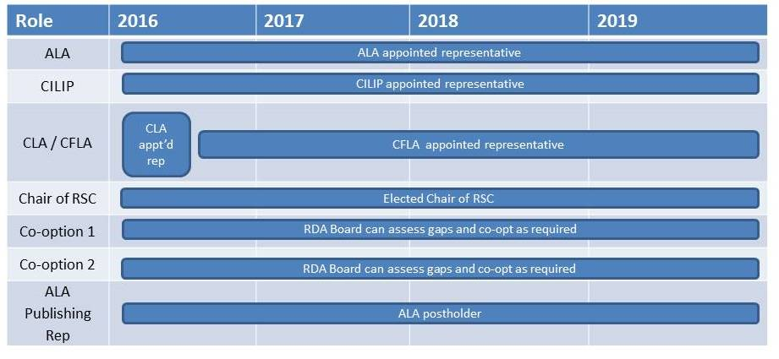

RDA Board Chair
CILIP will continue their term as Chair until 31st December 2018 to oversee the transition to the new governance structure.

In future, the terms of the RDA Board Chair and RSC Chair will be staggered to avoid that both post holders stepping down at the same time.

For the purposes of transition CFLA will take up the Chair in 2019 but will ensure that their term finishes (at the latest) 1 year in advance of the RSC Chair changing again.

National Institution representatives
The following diagram shows the transition to rolling terms for the National Institution representatives and the initial selection process timescales for those regions:

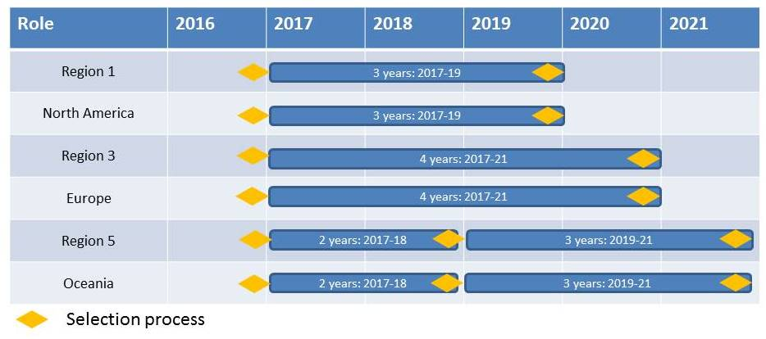

North American representative
Selection for the North American representative will be undertaken in November 2016. For the first selection process, nomination and selection is limited to current RDA Board institutions to aid transition. Selection for the 2020-2022 and all subsequent terms is open to any eligible National Institution.

European representative
Selection for the European representative will be undertaken in November 2016. For the purposes of transition, they will be selected for 4 years. After which the region will revert to the standard three year term. For the first selection process, nomination and selection is limited to current RDA Board institutions to aid transition. Selection for the 2021-2023 and all subsequent terms is open to any eligible National Institution.

Oceania representative
Selection for the Oceania representative will be undertaken in November 2016. For the purposes of transition, they will be selected for 2 years. After which the region will revert to the standard three year term. For the first selection process, nomination and selection is limited to current RDA Board institutions to aid transition. Selection for the 2019-2021 and all subsequent terms is open to any eligible National Institution.

Africa, Asia, Latin America and the Caribbean representatives
RDA Board will identify the readiness of currently un-represented regions to enter a selection process by looking at the list of institutions that subscribe within each of the three regions. From this list they will identify any institution that meets the agreed definition of a National Institution representative. The Board should then seek to identify whether they have or will be implementing RDA in the next year. Where there are relevant institutions, RDA Board should implement selection processes for the region.

The RDA Board has the flexibility to appoint each of these regions to the most appropriate rolling term (Region 1, Region 3 or Region 5) to aid transition.

Transition period co-options for current Board members
Where places on the Board exist due to Africa, Asia, Latin America and the Caribbean representatives not being appointed, the RDA Board will offer those National Institutions currently sitting on the Board but not selected to represent their region the opportunity to remain on RDA Board as a co-option. These institutions will be appointed with a temporary rolling year term until whilst places remain available. This will aid transition and decision making in the interim.

Transition plans for the RDA Steering committee

Core RSC roles
This diagram outlines the three roles on RSC which are defined by people occupying specific roles:
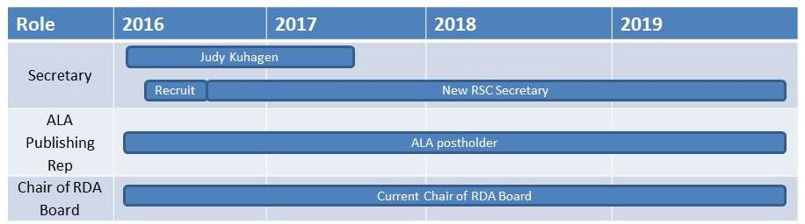

Regional representatives
The following outlines the current transition plan for regional representatives:
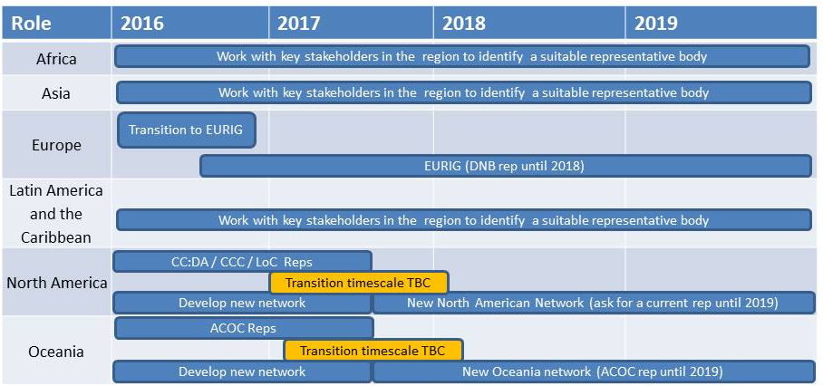

Europe
EURIG has been identified as the ideal body to represent of the needs of European communities. We have therefore been working towards a transition with the goal of the Europe representative being implemented for the 2016 RSC meeting.

North America
Representatives from the current North American constituencies have met to discuss and create a solution which will see a new ‘light-weight’ layer sit over current constituencies.

A working name of the North American RDA Committee (NARDAC) has been suggested. The network will include representatives from American Library Association (ALA), Canadian Committee on Cataloguing (CCC) and Library of Congress (LC).

RDA Board have asked for NARDAC to be formally constituted by December 2017.

Oceania
The Oceania network will build on the tradition of close partnership working. Representation on the RSC will rotate between Australian Committee on Cataloguing (ACOC) in Australia and New Zealand’s Cataloguing Special Interest Group (CATSIG). It is believed the groups can work together effectively on RDA matters with a regular schedule of teleconferences (much as they do now). When more numbers emerge in the region, they would consider establishing a separate group. It is currently planned that they will adopt a similar naming convention to North America and become the Oceania RDA Committee (ORDAC)

RDA Board have asked for ORDAC to be formally constituted by December 2017.

Africa, Asia, Latin America and the Caribbean
The Chair of the RDA Board and Chair of the RDA Steering Committee will seek intelligence from the three regions and identify any regional community groups which could undertake a regional role.

Rotating roles
The following diagram identifies the transition to the new terms of appointment for the rotating roles on the Steering Committee.

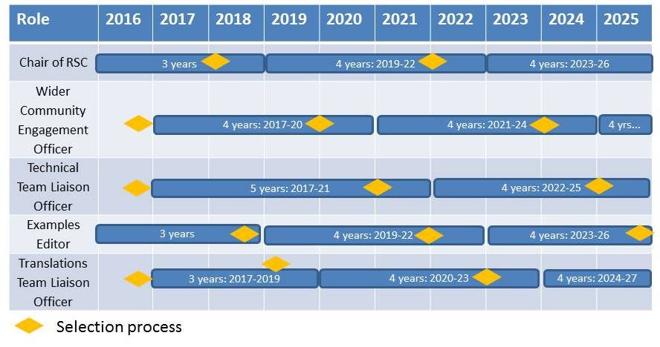

Updating the 1989 agreement
Since the Board has approved the move away from specific institutions being represented on the RDA Board, it no longer makes sense for specific organisations to be represented in the agreement. If this was continued, the agreement would need to be updated on an annual basis to take account for the different organisations being selected to represent regions at Board and Steering Committee.

It is therefore been agreed that the agreement be revised to reflect the agreement between the co-publishers with a clear articulation of the governance model and the selection processes for both the RDA Board and Steering Committee.

Date: 14 May 2018

Appendix 1 – Overall governance model

Appendix 2DA Board

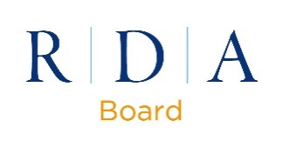

Appendix 3 Steering Committee
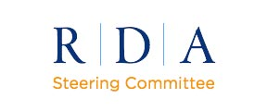

Appendix 4 - The role of the regional representative to RSC

The role of the Regional Representative is to:
- Represent the interests of the region on the RSC
- Prepare revision proposals and discussion papers on behalf of and in consultation with their communities
- Prepare discussion documents to explore topics before the proposal stage, or to handle a specific assignment from the RSC
- Prepare Fast Track proposals for minor changes and respond to the Fast Track proposals from other members
- Consult the region on discussion papers and proposals that have been submitted to RSC and reflect the breadth of responses back to RSC
- Actively contribute to RSC discussions and provide feedback on discussion papers, proposals and fast track proposals
- Attend RSC meetings and teleconferences
- Contribute to the review and signing-off on approved derivatives of RDA content (excluding translations)
- Consider other issues related to the development of RDA
- Sponsor/present workshops, programs, etc., at meetings of library associations
- Volunteer to represent the RSC at conferences, to act as liaisons to other bodies, and to prepare discussion papers on request

