EURIG 2018 – Practical information

Venue
DBC – Dansk BiblioteksCenter (Danish Bibliographic Center)
Tempovej 7-11
2750 Ballerup Denmark
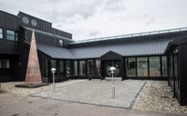
Hosts: DBC http://www.dbc.dk/english
In cooperation with: Danish Agency for Culture and Palaces: https://english.slks.dk/

Metro Directions
From Copenhagen Central Station as well as other metro stations in the center of Copenhagen you will be able to take the S-train (line C or H, direction: Ballerup or Frederikssund). . Leave the train at Malmparken Station, go downstairs and under the railway bridge, and follow the path to DBC.
The journey takes approximately 25 minutes and it takes about 5 minutes to walk from Malmparken Station to DBC.
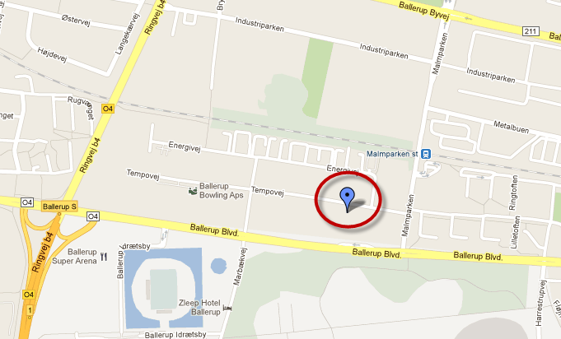
If you are coming from Copenhagen Airport take the metro from the airport to Vanløse. In Vanløse you will be able change to the S-train for Malmparken as described above.
You can plan your journey at https://www.rejseplanen.dk/webapp/index.html?language=en_EN
Further information about tickets etc. can be found at: http://www.visitcopenhagen.com/copenhagen/transportation/transport-and-around-copenhagen

Where to stay
Even though there are hotels near DBC we would recommend you stay in the center of Copenhagen.
At http://www.visitcopenhagen.com/copenhagen/hotel-guide you will find a wide range of possibilities.

Catering and Dinner
The hosts will provide coffee and lunch during the meetings.
There will be a group dinner on Thursday evening (May 24) at 7:00 pm at your own expense. Further information will follow.
When registering for the members meeting please inform us whether you will join us for dinner.

