EURIG

Minutes of the Members’ Meeting, 2017
Hosted by Casalini Libri
Fiesole, Italy, 10. May 2017

Content
1 Welcome and introductions 3
2 Minutes of the previous meeting and matters arising 3
2.1 Actions from the 2016 Member’s meeting 3
2.2 EURIG Co-operation Agreement 3
3 Annual Report and Membership Update 4
4 Reports of the Europe Regional Representative to RSC 6
5 Discussion of 3R Project 6
6 Working Group Reports 7
6.1 Fictitious entities Working Group 7
6.2 Music Working Group 7
6.3 Places WG 7
6.4 RDA/ONIX Framework Working Group 7
6.5 Relationship Designators Working Group 7
6.6 Technical Working Group 7
6.7 Capitalization Working Group 7
6.8 Translations Working Group 7
7 Future meetings 7
7.1 RSC Meeting Chicago May 2017 7
7.2 European BIBFRAME meeting Frankfurt, 26-27th September 2017 7
7.3 RSC Meeting Madrid 2018 8
7.4 EURIG Members’ Meeting 2018 8
7.5 RDA Outreach meeting IFLA, Wroclaw (RSC, NUKAT, EURIG, ISBD) 25th Aug. 2017 8
7.6 RSC Meeting Madrid, October 2017 8
7.7 EURIG 2018 Meeting, Istanbul 8
7.8 EURIG 2019 Meeting 8
8 Election of committee members 8
8.1 Executive Committee 8
8.2 RSC Europe Region Representative 8
8.3 Editorial Committee 8
9 Communications and Any Other Business 9
10 Close 9
Appendix 1: Attendees 10
Appendix 2: EURIG Annual Report 2016-2017 12
Appendix 3: Objectives and outcomes 2016/2017 15
Appendix 4: Discussion on the role of the Europe Regional Representative to RSC 16
Appendix 5: Music Working Group 20
Appendix 6: RDA/ONIX Framework Working Group 21
Appendix 7: Technical Working Group report 22
Appendix 8: Capitalization Working Group report 23
Appendix 9: RSC Translations Working Group report 24
Appendix 10: Request for help to extend language support in RIMMF 25

The Business Meeting was restricted to members and invited guests only

Welcome and introductions
The Chair welcomed everyone to this year’s members’ meeting. There was a short round of introductions.
After the meeting a template for updating the website with current status of implementation plans etc. will be sent out. In that way we will get the same information from everyone.
Action: Executive Committee.

Minutes of the previous meeting and matters arising
The minutes of the previous meeting were reviewed. No further comments were received and the minutes were approved.

Actions from the 2016 Member’s meeting
1.3 Executive Committee: provide an appropriate place for recording implementation status and notify members.
Carried Forward: the wiki has been online for some time, but has not been widely used.
From now on we will use the new web site that is a part of the RSC web.
7.2 Executive committee to evaluate planning tools
Done: We have also looked at PB Works and Trello as tools for planning, but although both tools provide useful functionality, we have not needed to use them. The Editorial Committee has been able to use the infrastructure developed for DACH and The Executive Committee worked with Casalini to plan the2017 meeting.
7.3.1 All to send in nominations for Editorial Committee by 3rd June.
Done: Nominations for the editorial committee have been received.
7.4 RSC Rep to raise legal matters WG with RSC Chair
Done. The matter was however not taken forward by RSC, on the grounds that it is an issue that mainly affects Europe.
8.1 All members to consider whether they would commit to assist in maintenance of future EURIG website.
Done: British Library has agreed to do so.

EURIG Co-operation Agreement
Everyone has agreed and all have signed the Co-operation Agreement, apart from two institutions, British Library and the National Library of Norway.
The Chair moved that the adoption of the new agreement from 1st May 2017 should be minuted and this was agreed.
The Chair informed that the draft terms of reference for the Oceania region have been drafted and were circulated to the RDA Board.

Annual Report and Membership Update
The Chair went through the highlights of the annual report (appendix 2).
There has been great progress on the governance issues.
Concerning the objectives of 2016/2017, see the appended powerpoint (appendix 3).
We more or less met all our objectives for last year.
Membership update
EURIG now has 42 members from 26 countries.
We welcomed four new members this year: CILIP from UK, eLABa from Lithuania, National Library of Estonia and National Library of Israel.
We are hoping for some more interest from central Europe and the Balkans shortly.
In Western Europe, there are no members from Belgium or Ireland. The Chair noted that the British Library will be providing RDA training to EU libraries in Brussels in late May.
Regarding country updates they will be updated in the template being sent out as was already mentioned under item 1 on the agenda.
There was a question about a possible membership from the Library of Congress. The Chair replied that we have had one member from North America, who had been admitted because of their European customer base. However under the new cooperation agreement, it is not possible to admit members for whom a more appropriate regional representative body exists. The reason why Israel is with EURIG is that there still is no Middle East or Asian Region.
A discussion followed on the role of the EURIG Editorial Committee and the responsibilities of the members and the Europe representative to the RSC. The fact, that the representative will have to say YES or NO to every proposal brought forward, and by doing so representing all of Europe is a very difficult, if not impossible, situation.
The editorial committee members expressed a concern that they sometimes felt like hostages in the group. Representing all of Europe without knowing what all of Europe thinks is an impossible mission. But: We do have to be able to put our faith in some persons that they do their best for the whole. A question was put as to whether it is possible not to comment on everything, but to make a selection? The answer according to the Chair is YES. If there is insufficient time to respond, it is an issue with the process.
The Chair noted that it is much more efficient that we now evaluate everything collectively rather than as three separate constituencies, each of which contributes a separate response, all of which required review by RSC. Furthermore, RSC has a more strategic focus and when the 3R project is over the number of proposals is not expected to return to previous levels.
Françoise Leresche spoke for the members of the special working groups and stressed that it is not feasible to consult the whole EURIG community every time the special groups need to present their views.
The Chair suggested that there be longer time for evaluation and response to the proposals.
Action: The Executive Committee/Board Representatives to recommend an earlier deadline for submission of proposals.
The Chair noted that proposals had been available earlier in the past and that the ALA Annual conference should not continue to drive RDA development timetable.
Hanne Hørl Hansen proposed that the RSC each year concentrate on one part of the instructions, e.g. music, law, or something else considered important.
Discussion groups:
The meeting was thereafter divided into three informal discussion groups to consider the questions for European co-operation raised by Renate Behrens. The groups reported as follows:
Group 1 (Alan Danskin):
* We need more and better communication. The membership as a whole needs to know what is going on and need to know what their role is. A shared workspace is necessary for this. Members can feed in their comments there and the Editorial Committee can react to what is handed in.
* The issue of time scales. These are often far too short for effective evaluation of what is being proposed. Europe should recommend changing the RSC policies to allow time to translate documents before commenting on them.
* We need more European members in the RSC working groups. The list of back-up experts, created after the Bern meeting should be updated and be put on the web, so that working group members can provide other working group members with the sounding board and broader mandate they currently feel is lacking.
* The problem of the review process: The main issues are timing and duration. Proposals arrive in August when many experts are at IFLA or on leave. The publication date should be brought forward. Timing has been influenced by ALA Annual, but as work is increasingly done by international Working Groups the justification for this is declining. The Chair also noted that the customer base outside US is larger than within the US.
* Proposals from outside the working groups. Could those be brought forward by another EURIG member?
Group 2 (Hallfriður Kristjansdottír):
* The number of European representatives in RSC working groups must be higher.
* A better platform and a better communication way for European members are needed. There should be a possibility to mark things as urgent and get fast replies.
* More support on what a proposal means in practical terms should be given.
* Most comments also agreeing with previous group.
Group 3 (Hanne Hørl Hansen)
* The role of the wiki was discussed in this group. We need to improve the way we communicate new proposals from RSC and take in the replies to the Editorial Committee.
* We should better promote more initiatives at a European level. Maybe it could be a good idea to have some European focus areas where we have European expert groups; maybe we could have a group that could propose a better way of dealing with music within RDA. The groups should not be seen as permanent, but working for a limited period of time.
* A possibility would be an informal list of experts.
* Many comments are the same as previous groups.
The Chair posed one question: What is a minimum time scale for a time to respond to a proposal, maybe something like 10 working days? Is that a reasonable period? This has to do with the Editorial Committee and other members of the board having time to contact adequate experts to get their views. Proposals with a deadline in August being sent out early August should maybe be sent out in June instead?
Renate will take these views to the Chicago meeting. Informal information to the RSC will be delivered already now, but then the Executive Committee will develop a proposal for a change in advance of the meeting.
Action: The Executive Committee and Renate Behrens work on a proposal for a change.
This matter will be discussed further at today’s ad hoc executive committee meeting.

Reports of the Europe Regional Representative to RSC
Renate Behrens reported on the work of the Europe Regional Representative to RSC, aspects of which have been mentioned to a great extent in the item above already. Renate wanted to initiate a discussion on the role of the Europe Regional Representative, see PowerPoint as appendix 4.

Discussion of 3R Project
Reports from WG representatives.
Renate Behrens explained the project in broad terms. The new Toolkit will be a much more flexible tool than before. The project is implementing a new platform for translations. It was also noted that translation policy has changed to permit less literal translations. The language used can therefore be more attuned to the understanding of native speakers.
The first release is scheduled for April 2018. The older version will be included for some time as well.
As soon as Renate has information about previews of the new Toolkit she will provide it. However so far there are no screen shorts or any other hints about the look of it.
Some participants expressed worries about it being delayed. We cannot risk a cut in our production yet another time.
What we know is that the structure will change and that is of course worrying us a lot. New numberings will be a result and even though there is a promise that redirection will be automatic many of EURIG members were hesitant. Policy statements will most likely have to be rewritten, and amongst the people working with these, there is a large suspicion that the numbering of these will not be automatic.
There was a question as to whether the new toolkit connects with the database of languages of the European Union? Renate Behrens will look into that.
The Chair finally pointed out that we did agree to the LRM model within EURIG, and now we need to take the consequences. There might however be quite a threshold to get over.

Working Group Reports

Fictitious entities Working Group
Stefanie Zutter sent a short report after the 2017 meeting, added as appendix 5 to the minutes.

Music Working Group
Anders Cato gave a short report, added as appendix 6 to the minutes.

Places WG
Christian Aliverti reported that the working group had not been very active last year.

RDA/ONIX Framework Working Group
Alan Danskin has added a short report as appendix 7 to the minutes.

Relationship Designators Working Group
Maira Kreislere had no special report to give for this year.

Technical Working Group
Marja-Liisa Seppälä gave a short report, added as appendix 8 to the minutes.

Capitalization Working Group
Anders Cato and Marja-Liisa Seppälä gave a short report, added as appendix 9 to the minutes.

Translations Working Group
Marja-Liisa Seppälä gave a short report, added as appendix 10 to the minutes.

Future meetings

RSC Meeting Chicago May 2017
Next week there will be a meeting with the RSC in Chicago. Renate is taking part.

European BIBFRAME meeting Frankfurt, 26-27th September 2017
The Chair reported about the meeting and its agenda.

RSC Meeting Madrid 2018

EURIG Members’ Meeting 2018

RDA Outreach meeting IFLA, Wroclaw (RSC, NUKAT, EURIG, ISBD)
25th Aug. 2017

RSC Meeting Madrid, October 2017

EURIG 2018 Meeting, Istanbul
We will set up an organizing committee with representatives from the host institutions and the members of the Executive Committee.
Action: The Executive Committee sets up an organizing committee.
Tolga Çakmak confirmed that there is an expectation that there will be a one day seminar plus one day members’ meeting. Further details of timing, duration and programme to be agreed by the planning committee.

EURIG 2019 Meeting
Action: Please notify the new Executive Committee if you and your institution are interested in organizing a meeting in 2019.

Election of committee members

Executive Committee
Nominations had been received for each post. There were no contested posts, therefore no election was necessary. The meeting voted unanimously to approve the appointment of the new Executive Committee:
Office | 2017-19
Chair | Hanne Hørl Hansen (Denmark)
Vice-Chair | Marija Liisa Seppälä (Finland)
Secretary | Ahava Cohen (Israel)

RSC Europe Region Representative
Renate Behrens’ term as interim representative ends in 2018. Nominations are therefore requested for this role from 2018-2021. The Chair emphasized the importance of the role and the significant workload. Deadline is 1st October for nominations committee.
Action: all.

Editorial Committee
The changes to the Executive Committee mean that there will be some changes to membership/roles within The Editorial Committee. There is no maximum size, although practical limitations should be observed. At present there are 8 members and further nominations are sought.
Action: all.

Communications and Any Other Business
The Chair thanked the Casalini Libri representatives and the University of Florence on behalf of EURIG for an extremely well organized meeting and an excellent social program.
The Chair also thanked members for attending and for their many contributions over the three days.
Presentations from this year’s conference will be on a special website maintained by Casalini Libri. Papers will be presented in the first issue of JLIS of 2018.
During the conference Gabriele Meßmer retired and was thanked by Prof. Mauro Guerrini and others during the reception at Villa Torrossa, Fiesole. The Executive Committee also wish to recognise the contribution of Mar Hernández, a founder member of EURIG, who retired from the Bibloteca Nacional de España on 8th May.
The Chair reported that TMQ Developers of RIMMF are looking for assistance to extend multilingual support in RIMMF (RDA in Many Metadata Formats). Further details are in the attached email, see Appendix 11.
Roberto Gómez and Françoise Leresche have experience of this activity and can advise on workload.
Richard and Deborah Fritz will be in Europe (Krakow and Budapest during early June) and are willing to meet anyone interested, or you can email them.

Close
The Chair thanked everyone for a productive meeting and wished the new Executive Committee the best of luck in their work.
The meeting was followed by a short handover meeting between the old and the new executive committees.

Appendix 1: Attendees
Country | Name | Institution
Austria | Verena Schaffner | Austrian Library Network
Czech Republic | Jarmila Přibylová | National Library of the Czech Republic
Denmark | Anders Cato | Danish Agency for Culture and Palaces
 | Hanne Hørl Hansen | Danish Bibliographic Center, DBC
Estonia | Jane Makke | National Library of Estonia
Finland | Marja-Liisa Seppälä | National Library of Finland
France | Françoise Leresche | Bibliothèque nationale de France
Germany | Gabriele Meßmer  Renate Behrens  Rita Albrecht | Bayerische Staatsbibliothek  Deutsche Nationalbibliothek  HeBIS Central Office
Iceland | Ragna Steinarsdottír  Hallfriður Kristjansdottír | National and University Library of Iceland  National and University Library of Iceland
Israel | Ahava Cohen | National Library of Israel
Italy | Giovanni Aldi  Marreo Barrucci (observer)  Marisa Santarsiero (observer)  Cristina Salvani (observer) | Casalini Libri  Università L.Bocconi – Biblioteca  Università L.Bocconi – Biblioteca  Università L.Bocconi – Biblioteca
Latvia | Maira Kreislere  Anita Goldberga | National Library of Latvia  National Library of Latvia
Luxemburg | Stefanie Zutter | Bibliothèque nationale de Luxembourg
Netherlands | Lian Wintermans  Daniel van Spanje  Marja Smolenaars (observer) | National Library of the Netherlands  OCLC  National Library of the Netherlands
Norway | Frank B. Haugen | National Library of Norway
Poland | Leszek Śnieżko | NUKAT Center of Warsaw University Library
Slovakia | Martin Krejčí  Lúdmila Rohoňová (observer) | Slovak National Library  Slovak National Library
Slovenia | Irenca Kavčič | National and University Library of Slovenia
Spain | Roberto Gómez | National Library of Spain
Sweden | Katarina Synnermark  Olle Johansson (observer) | National Library of Sweden  National Library of Sweden
Switzerland | Christian Aliverti  Thierry Clavel | Biblioteca nazionale svizzera  RERO – Library Network of Western Switzerland
Turkey | Tolga Çakmak | Hacettepe University, Department of Information Management
United Kingdom | Alan Danskin | British Library
United States | Angela Kinney (observer) | Library of Congress

Appendix 2: EURIG Annual Report 2016-2017

Membership
EURIG has 42 member organizations in 26countries.
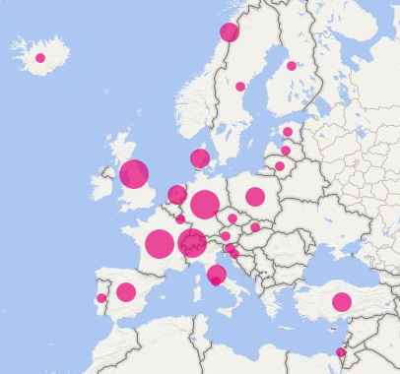
Four new members have joined during 2016-17:
- Chartered Institute of Library and Information Professionals (United Kingdom)
- The eLABa Consortium (Lithuania)
- The National Library of Estonia
- The National Library of Israel

One member has not yet approved the revised co-operation agreement.

Members’ Meeting 2016
The 2016 members’ meeting was hosted by the National Library of Latvia. The meeting was held in conjunction with the seminar RDA in the Baltics and Eastern Europe, a workshop on governance and a Jane-athon event. This series of events attracted more than 90 delegates. Further details of the meeting can be found on the website.

Governance
Members participated in a workshop on governance at the Riga meeting. The workshop established principles by which the Europe region should work. Members also agreed in principle to proposals for amending EURIG’s structure and processes for appointment of regional representatives to RDA Board and RDA Steering Committee. It was agreed to establish a EURIG Editorial Committee, Chaired by the RSC representative. These outcomes were subsequently incorporated in the revised EURIG Co-operation agreement, which was approved by members in March 2017 and will come into effect from 1st May, 2017.

The terms of the elected officers expire in May 2017. Nominations were sought for 2017-2019 term. As only 3 nominations were received, no election will be required and the new Executive Committee will take office following the 2017 Members’ Meeting.

Office | Incumbent | 2017-19
Chair | Alan Danskin (UK) | Hanne Hørl Hansen (Denmark)
Vice-Chair | Verena Schaffner (Austria) | Marija Liisa Seppälä (Finland)
Secretary | Anders Cato (Denmark) | Ahava Cohen (Israel)
Interim RSC Representative* | Renate Behrens (Germany) | Renate Behrens (Germany)

*Ex Officio member
RDA Implementation
The following implementations were announced in 2016-2017
- Iceland implemented RDA during 2016.
- The Danish Agency for Culture and Palaces announced that Denmark will implement RDA with effect from 1st January 2018.
- The National Library of Spain decided to adopt the standard RDA: Resource Description and Access for cataloging their collections, with effect from 1st January 2019.
Many other members continued to progress implementations that are already underway. There is an outstanding action on The Executive Committee to develop a roster showing members’ implementation status. This will be taken forward in the new pages.
RDA Development
EURIG formed an interim Editorial Committee (The Editorial Committee) in July 2016 to coordinate responses to RDA proposals. DNB kindly allowed EURIG to share the infrastructure developed to facilitate the DACH community’s work. The current membership of the Editorial Committee is:
- Renate Behrens (DNB, Chair, Interim RSC Representative)
- Anders Cato (Danish Agency of Culture and Palaces, Secretary)
- Christian Aliverti (National Library of Switzerland)
- Alan Danskin (BL, EURIG Executive Committee representative)
- Hanne Hørl Hansen (Danish Bibliographic Agency)
- Hallfríður Kristjánsdóttir (National and University Library of Iceland
- Marja-Liisa Seppälä (National Library of Finland)
- Christoph Steiger (University of Music and Performing Arts Vienna)

The Editorial Committee discussed the 2016 RSC papers, taking account of national discussions and prepared the responses, in a series of virtual meetings during September. The committee has met on two subsequent occasions.
Renate Behrens represented the Europe Region at the November 2016 RSC Meeting hosted by DNB in Frankfurt.
EURIG members serve on the following RDA Working Groups.
Aggregates | Françoise Leresche (BNF); Clément Oury (ISSN); Marija Liisa Seppälä (NL Finland),
Capitalization | Anders Cato (Danish Agency for Culture & Palaces); Mauro Guerrini (University of Florence,Italy); Anita Krawalski (Deutsche Nationalbibliothek, Germany) Marija Liisa Seppälä (NL Finland); Marja Smolenaars (KB)
Music | Anders Cato (Danish Agency for Culture and Palaces)
Places | Christian Aliverti (Swiss National Library); Esther Scheven (DNB)
Rare materials | Michael Beer (Bayerische Staatsbibliothek); Adelaida Caro Martín (Biblioteca Nacional de España); Peter Sjovist (Uppsala University, Sweden)
RDA/ONIX Framework | Alan Danskin (British Library); Françoise Leresche (BNF)
Technical | Sarah Hartmann (Deutsche Nationalbibliothek); Ricardo Santos Muñoz (Biblioteca Nacional de España); Marja‐Liisa Seppälä (National Library of Finland)

EURIG members also contribute to translations and to the development and delivery of RDA training throughout the Regions. A series of Jane-athon events were hosted in 2016 by EURIG members and moderated by RSC Chair and Deborah Fritz.

Communications
The Executive Committee has worked with ALA Publishing to migrate the EURIG website to the RSC site. This work is currently in progress. Core content has been migrated to enable a soft launch in early May and resources are in place to complete the migration before the current site is closed down on 30th June.
The Executive Committee also looked at Trello and PB Works as potential tools for shared planning and collaborative working. Both have considerable potential, but for practical reasons we have relied on DNB’s infrastructure this year.

Appendix 3: Objectives and outcomes 2016/2017

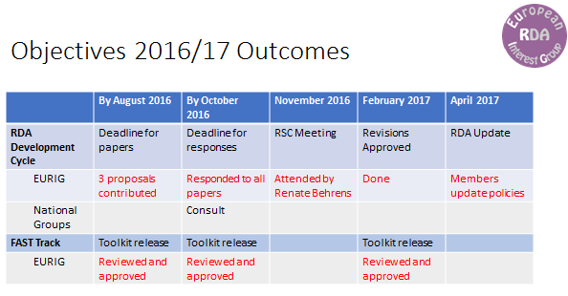

Appendix 4: Discussion on the role of the Europe Regional Representative to RSC

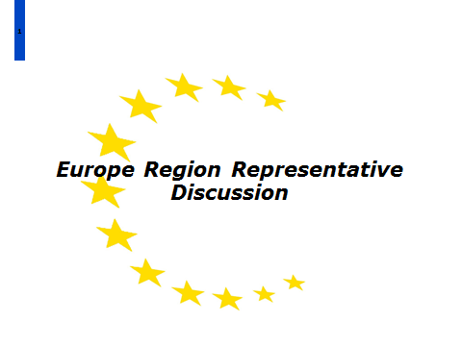

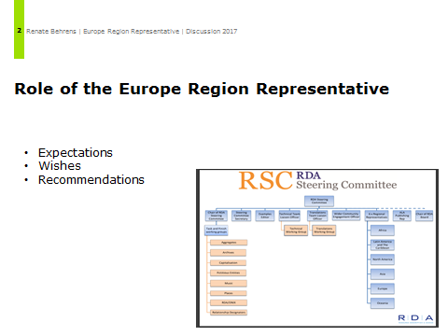
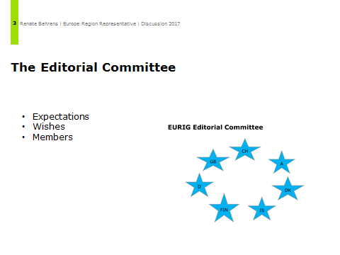

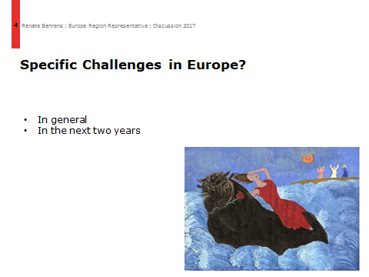
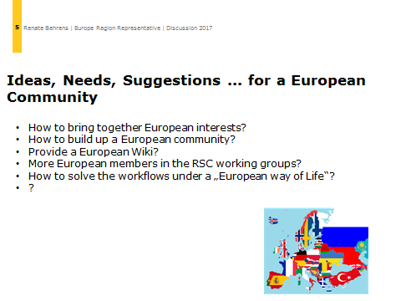

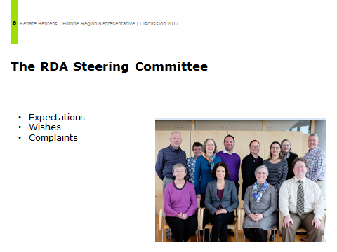
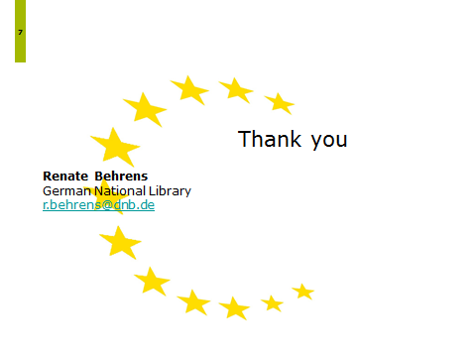

Appendix 5: Fictitous Entities Working Group
Membership
- Gordon Dunsire (RSC)
- Mary Anne Dyer (Virginia Commonwealth University, USA)
- Sandra Macke (Multnomah County Library, Oregon, USA)
- Robert Maxwell (Brigham Young University, USA)
- Richard Moore (British Library, UK)
- Gayle Porter (Chicago State University, USA)
- Mark Scharff (Washington University in St. Louis, USA)
- Amanda Sprochi (University of Missouri, USA)
- Stephanie Zutter (National Library of Luxembourg)
The working group had an interesting few months since the announcement of the new Library Reference Model (LRM) which warranted a major impact in the scope of authority data.
New entities have been created such as NOMEN, whereas PERSON, FAMILY, CORP BODY are considered as AGENT in the new RDA class set. According to LRM, only humans can be AGENT.
The issue at hand is now whether the current scope of RDA should be extended and include fictitious entities in authority data as NOMEN or whether the scope should be narrowed down to biological PERSON and exclude purported (fictitious) entities I the future.
Fictitious entities are
- Fictitious or legendary persons
- Persons and entities named in sacred scriptures
- Spirits
- Animals
Can fictitious entities be presented as a creator or contributor in the bibliographic universe? Who can, in LRM terms, be a creator (=AGENT)? Only a biological person or also a fictitious character or non-human character?
The discussion around this issue took months and is documented in working papers and in the email trail of the working group. To elucidate the question, several principles were taken into account such as the Theory of Mind, to answer the question whether animals should be given the right to be labelled as AGENTS in the bibliographic universe. Should Genghis Khan, Kermit the Frog, Geronimo Stilton, and other celebrities become access points as a PERSON or as a THING?
At the time of the conference, discussions were ongoing. A report on the decisions making is likely to be produced by Gordon Dunsire at the next EURIG meeting in 2018.

Appendix 6: Music Working Group
Activity of RSC Music Working Group in 2016-2017
EURIG members’ meeting, May 10, 2017
Membership
James Alberts (Library of Congress, USA)
Anders Cato (EURIG)
Jean Harden (University of North Texas, USA)
Mary Huismann (University of Minnesota, St. Olaf College, USA)
Damian Iseminger (Library of Congress, USA)
Kevin Kishimoto (Stanford University, USA)
Morris Levy (Northwestern University, USA)
Daniel Paradis (Bibliothèque et Archives nationales du Québec, Canada)
Working Group Meeting, Frankfurt am Main, February, 23, 2017

Discussion of the implications of the 3R project.
Discussions of old tasks and one new task, see below.
Tasks 2017
- Support the work of the 3R Project and provide expert advice.
- Investigate the composition and structure of statements about medium of performance, make recommendations on adding or modifying associated elements and sub-elements, and develop a draft of associated instructions within the framework of the new Toolkit structure. The Music WG should liaise with the Technical WG, and include the MARC 21 and UNIMARC treatment in its investigation.
- Investigate music vocabularies external to RDA and determine their suitability as sources of terms for music-related elements in the RDA element set.
- Revise RDA 6.28.1.1-6.28.1.8, based on responses to questions #2-#5 in 6JSC/MusicWG/Discussion/1.
- Prepare a discussion paper concerning performers as part of authorized access points for musical works, especially as it concerns jazz and popular music.
- Determine if terms for encoding formats related to musical notation are needed in RDA, in collaboration with the Technical Working Group.

May 1, 2017
Anders Cato
Danish Agency for Culture and Palaces
aca@slks.dk

Appendix 7: RDA/ONIX Framework Working Group
The group has been inactive and has not progressed its tasks during 2016-17.
The roster and task list for 2017-18 have been updated.
For further information see http://www.rda-rsc.org/sites/all/files/RSC-Chair-2-2017.pdf

Appendix 8: Technical Working Group report

Membership
- Gordon Dunsire (Chair, RSC)
- John Attig (Pennsylvania State University, USA)
- Deborah Fritz (TMQ, USA)
- Sarah Hartmann (Deutsche Nationalbibliothek)
- Diane Hillmann (MMA, USA)
- Ricardo Santos Muñoz (Biblioteca Nacional de España/EURIG)
- Marja-Liisa Seppälä (National Library of Finland/EURIG)

Outcomes 2016
The group submitted 2 proposals:
- RSC/TechnicalWG/1 (RDA models for provenance data):
  - suggested that the elements date of usage, scope of usage, status of identification and undifferentiated name indicator are considered as part of the development of the LRM nomen entity
  - suggested to generalize the scope of the elements cataloguer’s note and source consulted and to apply them to any RDA element
  - suggested to develop general guidance on provenance data
- RSC/TechnicalWG/2 (RDA 9.2: Addition of elements for Given name and surname):
  - suggested to add given name and surname as sub-elements of name of the person
  - suggested to add patronymic as a separate sub-element of name of the person

Tasks 2017, e.g.
- Support the work of the 3R project and provide expert advice
- Investigate what elements are suitable for inclusion in a structured description for each WEMI entity
- Investigate the utility of relationships between Nomen
- Clarify the relationship between Note on…elements and their root elements
- Investigate issues in other designation…elements
- Monitor the need for value vocabulary representations of the relationship elements and designators

Appendix 9: Capitalization Working Group report

Membership
Sue Andrews (University of British Columbia, Canada)
Carlo Bianchini (University of Pavia, Italy)
Anders Cato (EURIG)
Ageo García (Tulane University, USA)
Mauro Guerrini (University of Florence, Italy)
Anita Krawalski (Deutsche Nationalbibliothek, Germany)
Pat Riva (Bibliothèque et Archives nationales du Québec, Canada) - chair
Marja‐Liisa Seppälä (National Library of Finland)
Marja Smolenaars (National Library of the Netherlands)
Larisa Walsh (University of Chicago Libraries, USA)

Outcomes 2016
The group was not able to prepare a proposal paper about the content and coverage of the Appendix A.

Tasks 2017
- Support the work of the 3R project and provide expert advice
- Review the content and coverage of the Appendix A
- Identify gaps in the instructions A.0-A.9
- Identify updates needed in specific languages and create mock-ups for languages

After the RDA satellite conference to the IFLA WLIC in Columbus, four members of the Working Group met informally and discussed a partial inventory of existing capitalization instruction formulations prepared by the chair.
Members have confirmed their willingness to continue to serve, and to produce a discussion paper/proposal for 2017.

May 1-5, 2017
Anders Cato
Danish Agency for Culture and Palaces

Marja-Liisa Seppälä
The National Library of Finland

.

Appendix 10: RSC Translations Working Group report
Membership
- Daniel Paradis (Chair, for French translation)
- Anders Cato (for partial translation)
- Ida Conesa Sanz (for Catalan translation)
- Mauro Guerrini (for Italian translation)
- James Hennelly (Director, ALA Digital Reference)
- Octavio Rojas (for Spanish translation)
- Marja-Liisa Seppälä (for Finnish translation)

Outcomes 2016
The group covered the following issues:
- Electing a new chair
- Reviewing of the status of the RDA reference translation
- Trados, a new translation tool, was presented to ALA Publishing and two members of the WG
- Discussions about the impact of the 3R project on the translation workflow
- Discussions how the books of the bible should be handled in translations

Tasks 2017, e.g.
- Support the work of the 3R project and provide expert advice
- Implement Trados
- Refine processes for the translation
- Identify areas of RDA English which can be clarified for international users
- Test the functionality of the RDA Registry for managing multi-lingual vocabularies

Appendix 11: Request for help to extend language support in RIMMF
Here is the message from Richard Fritz of TMQ
“As for the language content, we are not able to do this ourselves. …We’d love to increase that capability. Ideally, the next languages to be added should follow the RDA master plan for translation (ask G about that); probably Greek, Swedish, and Italian are getting closer. But we need Help!
If your [EURIG] folks want to volunteer, I’d be happy to set them up. The way it works is
1) I send them an Excel sheet containing all of the program’s captions, that they then translate into their language (probably about 300 items) and return to me;
2) I give them an account on the wiki that is locked to a namespace for their language, and they translate the tutorials (at a minimum) and whatever other pages they want into their language.
3) Then the user can download RIMMF, go to the Language options page, download the Registry data for their language, switch the interface into their language, and voila. They can then begin their own RDA training in their own language, using the janeathon model or whatever else.

